*Article*

**Gear shifting in hyperthermophylic Archaea**

**Yanfei Zhang1, Thierry D. G. A. Mondeel1, Jacky L. Snoep2,3,4, Bettina Siebers5 and Hans V. Westerhoff1,3,4\***

1 Synthetic Systems Biology and Nuclear Organization, Swammerdam Institute for Life Sciences,   
University of Amsterdam, 1098 XH Amsterdam, The Netherlands; y.zhang2@uva.nl (Y.Z.)

2 Department of Biochemistry, University of Stellenbosch, Stellenbosch 7602, South Africa; j.l.snoep@vu.nl

3 The Manchester Centre for Integrative Systems Biology, Manchester Institute for Biotechnology,   
School for Chemical Engineering and Analytical Science, University of Manchester, Manchester M1 7DN, UK

4 Department of Molecular Cell Physiology, Vrije Universiteit Amsterdam, De Boelelaan 1085,   
1081 HV Amsterdam, The Netherlands

5 Molecular Enzyme Technology and Biochemistry (MEB), Biofilm Centre, Centre for Water and Environment Research (CWE), University Duisburg—Essen, Universitätsstr. 5, 45141 Essen, Germany; bettina.siebers@uni-due.de (B.S.)

**\*** Correspondence: H.V.Westerhoff@uva.nl; Tel.: +31-20-6 143163

Received: date; Accepted: date; Published: date

**Abstract:** The well characterized thermoacidophilic *Sulfolobus solfataricus* (*S. solfataricus*) thrives in extreme environments with temperatures between 60 and 90 °C and pH between 2 and 4. We here focus not so much on the challenge posed by each of these individual conditions, but by the challenge of the continuous variation of the challenges. In this study, we examine whether a phenomenon we call ‘gear shifting’ could be at play. We use the organism’s genome-wide metabolic map (Ulas et al., 2012), a thermodynamic analysis, and kinetic models based on parts of the metabolic map (Zhang et al., 2017) and focus on the various pathways from glucose to pyruvate as well as the different flux patterns through oxidative phosphorylation. Using flux balance analysis on the genome sequence-based metabolic map, we find a diversity of possible flux patterns with 8 different ATP yields. Using the transcriptome as basis, we find that also the expressed pathways allow for the operation of various parallel metabolic routes operating at different ATP costs or yields. This suggests that *S. solfataricus* may well run its metabolism through various metabolic pathways in parallel. In a non-equilibrium thermodynamic analysis, we show how transitions between flux patterns could be beneficial for the flux of ATP synthesis. We identify a mode of continuous variation of the ATP/catabolism stoichiometry that should be optimal for the organism if it is stressed energetically. The simulations with an *in silico* kinetic replica shows that the ATP/ADP ratio was indeed a strong determinant of the fluxes through the glyceraldehyde-3-phosphate dehydrogenase (GAPDH) plus phosphoglycerate kinase (PGK) pathway and non-phosphorylating glyceraldehyde-3-phosphate dehydrogenase (GAPN) (the alternative to GAPDH plus PGK). With the increase of ATP/ADP value, the flux of GAPDH decreased, whilst the flux through GAPN increased monotonically. Flux balance analysis further shows that with this different pathway allocation the harvest of Gibbs energy or biomass changes. Likewise, at different oxygen concentrations different electron transfer pathways may be used to best achieve certain objectives according to FBA. We identify these phenomena as ‘gear shifting’, which should enable organisms’ to enhance their fitness under conditions of time-variant challenges.

**Keywords:** Hyperthermophylic archaea; flux balance analysis; gear shifting; ATP maintenance; flux distributions; oxidases; non-equilibrium thermodynamics; metabolic rewiring; variable stoichiometries

**1. Introduction**

Gear shifting is best known from driving. Depending on the change of road conditions, the driver or the car itself needs to shift between gears. When driving on a flat highway, the highest gear will give the highest speed, while when driving uphill, shifting to a lower gear may increase the speed, as it is necessary to provide enough force to the wheels: the optimal gear is not always the highest. Does such gear shifting exist in living organisms as well? *Clostridium ljungdahlii* contains alternatives in its genome for various redox reactions. These produce different ATP/acetate ratios and have been proposed to engage in gear shifting (Mondeel et al., 2016).

A phenomenon similar to gear shifting exists in the emergence of many cancer cell types. Cancer cells tend to employ glycolysis or glutaminolysis to lactate rather than oxidative phosphorylation to provide ATP, even when oxygen is present, which is called Warburg or WarburQ effect (Damiani et al., 2017). Weglarz-Tomczak et al (Węglarz-Tomczak, Mondeel, Piebes, & Westerhoff, 2019) found that cell-nutrition impacted the Warburg effect in hepatocellular carcinoma cells. In the yeast *Saccharomyces cerevisiae*, fermentation is a major pathway for Gibbs energy harvest, even under aerobic conditions. However, when glucose becomes scarce, ethanol produced during fermentation is used as a carbon source, requiring a shift to respiration (Gasmi et al., 2014). These phenomena are not quite the same as gear shifting as they also involve switches in catabolic products: We shall here examine the related phenomenon of the shifting between different metabolic routes that connect the same substrate (such as glucose and oxygen) and the same product (-couple; such as CO2 and water). We hypothesize that such gear shifting is exquisitely important when energetic challenges arise such as a lowered Gibbs energy in the catabolic substrates, lowered Gibbs energy differences across catabolic reactions at high temperature due to negative reaction enthalpies, or increased ADP phosphorylation free energy.

In 1990, Archaea were identified as the third kingdom of life based on their 16S rRNA (Woese, 1990). Many properties distinguish them from most Bacteria and Eukarya and many through not all Archaea manage to survive conditions that are extreme for most Eukarya and Bacteria. The thermophilic Archaea even thrive on temperatures between 60 and 80 °C, while hyperthermophiles live in the temperature range from 80 to 113 °C (Stetter, 1999). Growth at high temperatures and low pH offers various challenges. Beyond pH and temperature themselves, these include spontaneous decomposition of metabolic substrates and intermediates, possibly including ATP and ADP, reduced oxygen tension and compromised substrate uptake. In order to solve these problems, extremophiles need to adopt special strategies. In this paper we ask whether in principle gear shifting could be one of these.

*S. solfataricus*, one of the best studied (hyper)thermophilic archaea optimally and growing at 80 °C (60-90 °C) and pH 2-4, will be focused on in this paper. This organism contains the non-phosphorylating glyceraldehyde-3-phosphate dehydrogenase (GAPN), which catalyzes the direct oxidation of glyceraldehyde-3-phosphate to 3-phosphoglycerate by NADP. The enzyme bypasses adenosine 5′-triphosphate (ATP) formation by substrate-level-phosphorylation of ADP via phosphoglycerate kinase (PGK). The kinetic parameters of the relevant enzymes have been determined experimentally and we therefore could implement kinetic modelling to demonstrate that at high temperatures this organism should be expected mainly to use the GAPDH and PGK pathway in the gluconeogenic direction, with the GAPN functioning in the catabolic direction (Zhang et al., 2017). As we shall show below, this is a form of gear shifting.

The fluxes through these pathways should however not only be determined by these three enzymes but also by their metabolic environment and ultimately the genome wide metabolism in the organism. And due to the lack of kinetic parameters for most enzymes, it is impossible to construct a genome-wide kinetic model. This left much of the issue unsettled.

Flux balance analysis (FBA) is a mathematical method for comprehending the possibilities for steady flow through a metabolic network and there is sufficient information (Ulas et al., 2012) for FBA to be able to deal with genome-wide metabolic fluxes in *S. solfataricus*. In the present study, we shall show, more in general, FBA how can be used to address gear shifting. Using the genome wide metabolic map of *S. solfataricus* we identify 4 different gear settings already in anaerobic catabolism alone and 8 in total and then explain on this genome wide basis why this organism is an obligate aerobe. Using non equilibrium thermodynamics we show that there should be an optimum gear setting from the perspective of maximizing growth rate and that this setting may change when the growing becomes tough thermodynamically. We shall also map the transcriptome data of *S. solfataricus* growing at different temperatures to the genome wide metabolic map to verify the existence of gear shifting between different pathways.

**2. Materials and Methods**

*2.1. Kinetic model demonstrating gear shifting in S. solfataricus*

Our starting point was the model published in 2017 by our group (Zhang et al., 2017). By varying the rate constant of the ATPase in the model, different ATP hydrolysis (or ‘NGAM’: Non Growth rate associated Maintenance) fluxes, as well as different ATP/ADP ratios and different fluxes through the different catabolic pathways were obtained. We used Copasi (COPASI 4.16, available online: http://copasi.org/News/2015/08/19/Release/) throughout for the modelling. This software and the model files can be found in the Github repository under the folder name “Models”.

*2.2. Genome-scale reconstruction of S. solfataricus*

Our starting point was the previously published genome-scale metabolic map (GEMM) of *S. solfataricus* by (Wolf et al., 2016). We obtained the SBML file of the reconstruction through <https://fairdomhub.org/models/225> on April 24th 2018. We changed the reactions shown in Table 1. We did this to deal with proton imbalance and the different written forms for the protons (In the original model, both H+_rc and H+_ex represent the protons outside the membrane). We added Psi to deal with the transmembrane electric potential difference (outside minus inside; in terms of number of elementary charges). Besides the above modifications we also changed the reactions catalyzed by glyceraldehyde-3-phosphate dehydrogenase as reversible ones. The file named as “modification of the original model” can be found in the Github repository under the folder name “data”. Table 1 shows how the reactions were modified.

**Table 1.** The modified reactions. Before using the model, we modified some reactions because of a proton imbalance problem and in order to deal with the transmembrane electric potential difference (Psi).

|  |  |  |  |
| --- | --- | --- | --- |
| Reaction id | Original reaction | After changing | Reasons |
| carb_degra_1.2.1.26_R01752 | D__glyceraldehyde + H2O + NADP+ --> D__glycerate + H+ + NADPH | D__glyceraldehyde + H2O + NADP+ --> D__glycerate + 2.0 H+ + NADPH ¹ | Proton imbalance |
| oxp_redox_1.10.3.13_soxABCD_TRANS__RXN__240 | 6.0 H+ + 0.5 oxygen + representative_quinol --> 4.0 H+_rc + H2O + representative_quinone | 4.0 H+ + 0.5 oxygen + representative_quinol --> 4.0 H+_ex + H2O + 4.0 Psi + representative_quinone ² | Unification of the proton written forms and adding of Psi |
| oxp_redox_1.10.3.13_soxM_TRANS__RXN__240 | 2.0 H+ + 0.5 oxygen + representative_quinol --> 2.0 H+_rc + H2O + representative_quinone | 2.0 H+ + 0.5 oxygen + representative_quinol --> 2.0 H+_ex + H2O + 2.0 Psi + representative_quinone | Unification of the proton written forms and adding of Psi |
| oxp_redox_1.10.3.13_doxABCDE_TRANS__RXN__240 | 2.0 H+ + 0.5 oxygen + representative_quinol --> 2.0 H+_rc + H2O + representative_quinone | 2.0 H+ + 0.5 oxygen + representative_quinol --> 2.0 H+_ex + H2O + 2.0 Psi + representative_quinone | Unification of the proton written forms and adding of Psi |
| oxp_3.6.3.14_ATP__synthase | ADP + 4.0 H+_rc + phosphate --> ATP + 4.0 H+ + H2O | ADP + 4.0 H+_ex + 4.0 Psi + phosphate --> ATP + 3.0 H+ + H2O ³ | Unification of the proton written forms, proton imbalance and adding of Psi |
| T_symporter_(S)__lactic_acid | (S)__lactic_acid + 2.0 H+ <--> (S)__lactic_acid_ex + 2.0 H+_ex | (S)__lactic_acid + 2.0 H+ <--> (S)__lactic_acid_ex + 2.0 H+_ex + 2.0 Psi | Adding of Psi |
| carb_glucneo_1.2.1.13_GAPDHSYNEC__RXN_NAD | 1,3__bisphospho__D__glycerate + H+ + NADH --> D__glyceraldehyde__3__phosphate + NAD+ + phosphate | 1,3__bisphospho__D__glycerate + H+ + NADH <--> D__glyceraldehyde__3__phosphate + NAD+ + phosphate | Changed to reversible |
| carb_glucneo_1.2.1.13_GAPDHSYNEC__RXN_NADP | 1,3__bisphospho__D__glycerate + H+ + NADPH --> D__glyceraldehyde__3__phosphate + NADP+ + phosphate | 1,3__bisphospho__D__glycerate + H+ + NADPH <--> D__glyceraldehyde__3__phosphate + NADP+ + phosphate | Changed to reversible |

¹ This reaction involves transporting of H from H2O to NADP+ and replacing an H from glyceraldehyde using OH from H2O to produce glyceric acid. Here glycerate functions as glycerate anion, so 2 H+ should be produced. The reduction of NADP+ by 2 electrons to NADPH is assumed to consume one proton.

² H+_rc refers to the proton outside. H+ refers to intracellular protons

³This reaction can also be obtained by subtracting the following two reactions:

4 Psi + 4 H+_rc +ADP3- + phosphate2- -> ATP4- + H2O +3 H+

phosphate 2- + H+ -> phosphate- (at pH7 phosphate is taken as 1-, ATP as 4- and ADP as 3-; even though *S. sulfataricus* is an acidophile its intracellular pH is not far from neutral; The proton pumping stoichiometry is taken to equal 4 protons per ATP).

This genome wide metabolic model contains 992 reactions with 866 metabolites. Its *in silico* growth medium consisted of glucose, oxygen, phosphate, sulfate, ammonium, H+, H2O, Co2+. The import reactions were provided with the lower bound of -1000 except the import reaction for glucose (The lower bound of this reaction was set to -1; negative fluxes refer to uptake).

*2.3. Flux balance analysis*

Flux balance analysis (FBA) is a widely used approach for predicting the optimal flux patterns through biochemical networks at steady state (Orth, Jeffrey D., Ines Thiele, 2011). It is especially useful for researching genome scale metabolic network reconstructions, as it requires no additional knowledge with the exception of the network’s objectives. The steady state condition is represented by the formula S·v = 0, where S is the stoichiometric matrix with corresponding stoichiometric coefficients, stands for matix multiplication, *v* is the column vector of steady state fluxes through all the steps (vertices) in the network and 0 is a column vector of zero’s. FBA maximizes or minimizes an objective function Z = cT·v, where cT is a row vector of weights, indicating how much each reaction contributes to the objective function Z. For all fluxes upper and lower bounds need to be indicated, but for all but one, these can be set fairly arbitrary. With this, FBA is a linear programming problem. The output of FBA is a flux distribution which minimizes or maximizes the objective function. The biomass reaction (see below) was used as the objective function. Its detailed description is in the paper published by Ulas et al. (Ulas et al., 2012). Here in the medium the carbon source was glucose and the nitrogen source was ammonium. The biomass reaction sums the millimolar amounts of each precursor required to synthesize 1 gram dry weight of the organism (mmol gDW-1) (The file named as “biomass_equation_table” which shows this calculation can be found in the Github repository under the folder name “Data”).

¹

¹ In this biomass reaction ATP is not contained, it is used in another reaction named GAM (Growth Associated Maintenance) reaction. GAM is written in the following way:

In the above equation ‘EXP(-0n)’ means 10-0n, i.e. EXP(-04)=10-4.

*2.4. Mapping transcriptome to genome wide metabolic map*

The transcriptomic data from four microarrays of the two biological samples (the cells growing at 70 and 80 ℃) were partially mapped to the genome wide metabolic map to check the rewiring of the metabolic pathways. The data (The data is in the excel file named “80vs70 ArrayData”, and it can be found in the Github repository under the folder name “data”.) were obtained by collaborators in the group of J. van der Oost of the Wageningen University and part of the data has been published in 2009 (Zaparty et al., 2009).

Sometimes variation in the expression of a metabolic gene between two growing conditions does not affect the corresponding biochemical reaction. This can be because the enzyme that catalyzes the reaction is a multi-subunit enzyme encoded by more than one gene, and the gene of which the expression level changes remains above the expression level of one of the other subunits. Alternatively, the reaction may be catalyzed by more than one isozyme, the change in expression of the one enzyme being compensated for by an opposite change in expression of a different isozyme. Gene-reaction rules in the genome wide metabolic map contain the information on how many subunits an enzyme has, and on how many isozymes can catalyze a reaction. These gene-reaction rules can be used for calculating a Reaction Activity Score (RAS) when trying to map the transcriptomic data to the genome wide metabolic map (Damiani et al. 2019).

As the genome wide metabolic map published by (Ulas et al., 2012) does not contain the information of gene-reaction rules, we put this information in the supplementary file named “gene reaction rule”. We obtained this information by searching in the databases KEGG and Uniprot for *S. solfataricus* according to the EC number in the reaction id in the map. The RAS of a reaction was obtained by adding the expression levels of the isozymes or taking the smallest of the expression levels of the subunits of the multi-subunit enzymes. The codes that were used for calculating the RAS is in the file “RAS at different temperatures (70 and 80 ℃)” found in the Github repository under the folder name “Codes”. For the reactions that can happen spontaneously, the RAS was set to such a high number that it did not influence the results. For the details regarding how the RAS was translated into the bounds of the reactions, see the file named “Mapping RAS to the bounds of the reactions” found in the Github repository under the folder name “Codes”.

*2.4. Visualization of flux distributions*

Using the ‘Escher’ software package (King et al., 2015) we produced a map of a subset of the reactions of the genome-scale map. This static map was used, with help of the COBRApy package (Ebrahim, 2013), to visualize flux distributions. All the images obtained in this study are provided as in PNG format in the Github repository under the folder name “data”.

*2.5. Reproducibility*

The Python script, the original and the modified maps, the Copasi models are available as supplementary files. Furthermore, we provide, as a supplementary file, a Jupyter notebook that reproduces all the analyses discussed in this work. All the discussed models, model analysis code and the visualizations are available on a publicly available Github repository at: https://github.com/YanfeiZhang1208/Gear-shifting.

**3. Results**

*3.1. Why there is no shift from respiration to fermentation in S. solfataricus*

Many microorganisms can shift from fermentation to respiration. In *S. cerevisiae* (baker’s yeast) growing on ample glucose, for instance, fermentation to ethanol plus CO2 is the major pathway for Gibbs energy harvest, even under aerobic conditions. However, when glucose becomes limiting, a shift from fermentation to respiration occurs (Verduyn et al., 1984) (Gasmi et al., 2014). In *L. lactis*, the main fermentation route produces lactate, but there are alternatives towards acetoin, acetate, diacetyl and butane diol (Hoefnagel et al., 2002). *S. solfataricus* which has been found to be an obligate aerobe (Simon et al., 2009) (Ulas et al., 2012) suggest that it is unable to engage in any of these shifts. This could either be because its genome does not contain the genes required to catalyze the corresponding flux along any possible pathway, or because it does not express these genes. In order to examine the former possibility, we used the genome-wide DNA-based (and thereby expression independent) metabolic map and asked for growth (i.e. making the biomass production reaction the objective of a flux balance analysis). We found that the complete metabolic map with oxygen available to it could produce flux to biomass (Number 1 in Table 2), but that it could not grow when we blocked the reaction for importing oxygen (Number 1 in Table 2).

**Table 2** The fluxes computed for the genome wide metabolic network through the indicated reaction as objective function and with the changes indicated in the “Action” column to the reactions shown in the “Reaction_id” column. The fluxes are given in mmol per gram dry weight per hour, except for biomass, which is per gram dry weight per hour. The file named “checking 3.1 and 3.2” found in the Github repository under the folder name “codes” showed all the simulations.

|  |  |  |  |  |
| --- | --- | --- | --- | --- |
| Number | Reaction id | Action | Objective reaction | Flux |
| 1 | --- | --- | Biomass | 0.063 |
| 2 | T_flux_oxygen | Blocked | Biomass | 0 |
| 3 | T_flux_oxygen | Blocked | T_flux_(S)__lactic_acid | 0 |
| 4 | T_flux_oxygen | Blocked | T_flux_ethanol | 0 |
| 5 | T_flux_oxygen | Blocked | T_flux_ethanol | 0 |
| pyruvate_decarboxylase_to_acetaldehyde | Added |
| 6 | T_flux_oxygen | Blocked | T_flux_(S)__lactic_acid | 2 |
| prot_prot__lactate (protonation reaction of lactate to lactic acid) | Changed to reversible |
| 7 | T_flux_oxygen | Blocked | T_flux_ethanol | 0 |
| T_ABC__transporter_ethanol | Changed to reversible |
| 8 | T_flux_oxygen | Blocked | T_flux_ethanol | 2 |
| pyruvate_decarboxylase_to_acetaldehyde | Added |
| T_ABC__transporter_ethanol | Changed to reversible |
| 9 | T_flux_oxygen | Blocked | T_flux_ethanol | 2 |
| pyruvate_decarboxylase_to_acetaldehyde | Added |
| ethanol_diffusion | Added |
| 10 | T_flux_oxygen | Blocked | Biomass | 0 |
| prot_prot__lactate | Changed to reversible |
| 11 | T_flux_oxygen | Blocked | Biomass | 0 |
| pyruvate_decarboxylase_to_acetaldehyde | Added |
| ethanol_diffusion | Added |
| 12 | T_flux_oxygen | Blocked | Non-growth rate dependent maintenance ATP hydrolysis (NGAM) | 1 |
| prot_prot__lactate | Changed to reversible |

A possible explanation for this phenomenon could reside in the absence of enzymes for producing or exporting lactate, or for producing ethanol plus carbon dioxide from pyruvate and exporting the ethanol. We searched for the relevant enzymes (lactate dehydrogenase, pyruvate decarboxylase and alcohol dehydrogenase) and transporters (of lactate and ethanol), and we found lactate dehydrogenase and alcohol dehydrogenase but did not find the standard pyruvate decarboxylase in the genome wide map.

In order to examine why the organism would not be able to ferment to lactate, we implemented a procedure that we call ‘Metabolic Task Analysis’ (MTA), i.e., we made flux through the lactic acid export reaction the objective function of an FBA. Again blocking the import of oxygen, we found that the flux was 0 (Number 3 in Table 2). We also made the alcohol dehydrogenase reaction the objective reaction and again found a zero flux (Number 4 in Table 2). The map does contain a pyruvate decarboxylase reaction, but this is not the standard reaction known from *S. cerevisiae*: it is coupled to the reduction of quinone and produces acetate rather than acetaldehyde. Anaerobically it should be difficult to recycle the quinol produced into the quinone required for this reaction. In order to examine whether this was the sole cause for the lack of ability to ferment to ethanol and CO2, we temporarily added the acetaldehyde producing pyruvate decarboxylase reaction to the map, and used the ethanol export reaction as the objective reaction, FBA still showed the same result of zero flux (Number 5 in Table 2). This shows that the enzymes as specified in the *S. solfataricus* metabolic map do not suffice for engaging in the fermentation reactions, neither the alcohol fermentation executed by *S. cerevisiae*, nor the lactic acid fermentation executed by *Lactococcus lactis* (*L. lactis*).

We then checked the transport reaction for lactic acid. We noted that the deprotonation reaction from lactic acid to lactate was taken to be irreversible. This is highly unrealistic for protonation reactions and we therefore turned this reaction reversible (number 6 in Table 2). This did enable flux to extracellular lactate and thereby fermentation. We conclude that the more realistic version of the genome wide map of *S. solfataricus* does support fermentation from glucose to lactate. The corresponding flux pattern is shown in Figure. S1.

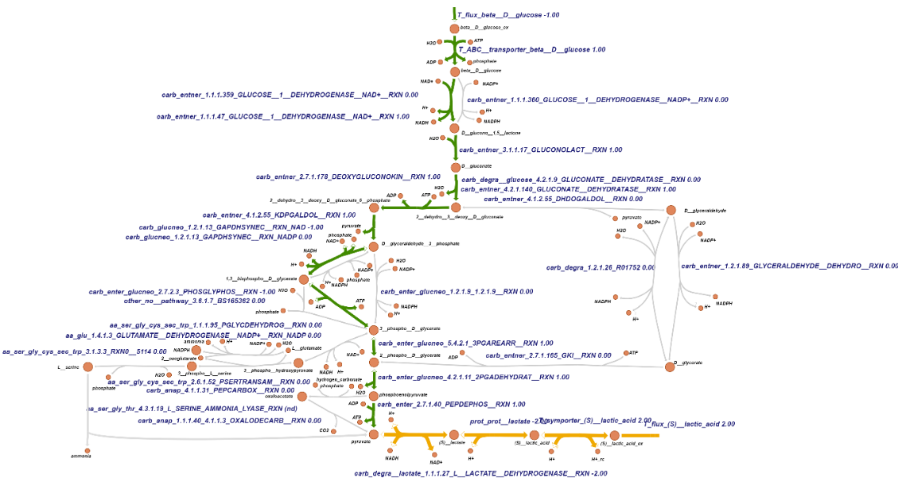

**Figure S1**. Visualization of the flux distribution when asking for anaerobic lactic acid production on glucose and with a reversible lactate protonation reaction. The maximum uptake of extracellular glucose was fixed at 1 mmol gDW-1 h-1, the import of oxygen was blocked and lactic acid export reaction was used as objective reaction for flux balance analysis.

Next we made all protonation reactions in the genome wide map reversible but we still did not see ethanol fermentation. We then turned to transport. From our map, we inferred that the map’s transporter reaction for ethanol can only transport ethanol from outside to inside the cell membrane. Since the transporter links this import of ethanol to the hydrolysis of ATP, such an assumed irreversibility is realistic. The absence of a possibility of ethanol to flow out of the cell is however unrealistic. Ethanol even more than water is fairly permeant through most biological membranes (Hannoun et al., 1986), but then in a process not coupled to ATP synthesis. When we made the ATPase driven import of ethanol reversible, and repeated the flux balance analyses (Number 7, 8 in Table 2) we obtained flux when adding the pyruvate decarboxylase reaction, which means in this way the FBA did show fermentation to ethanol. We then returned the ATPase driven ethanol transport reaction into its irreversibility and added a passive ethanol transport reaction and flux through ethanol export reaction became possible (Number 9 in Table 2). These fluxes still depended on the addition of the pyruvate carboxylase producing acetaldehyde however and should thereby be considered unrealistic.

Then we asked if the organism was able to grow anaerobically after making the lactic acid (or ethanol) transporter reaction reversible. Even though lactic acid or ethanol could be produced (see above), the answer was ‘No’ (Number 10 and 11). We conclude that the organism’s inability to engage in fermentation was not only due to the lack of the fermentation enzymes. The file named “checking 3.1 and 3.2” found in the Github repository under the folder name “codes” showed the simulations.

*3.2. Alternative pathways that might enable fermentation*

From the above section we conclude that the organism’s inability to engage in fermentation was not only due to the lack of the fermentation enzymes. Growth requires ATP. We therefore used MTA to examine if the proposed fermentation pathway from glucose to lactate could yield any ATP: we made flux through the ATP maintenance reaction the task, i.e. took that as the objective in FBA. By forcing flux through the glucose uptake system, we found that fermentation in *S*. *solfataricus* could proceed in principle, but only with production of 1 ATP (Number 12 in Table 2) (The corresponding flux pattern is shown in Figure S1.). The production of the ATP was driven by the proton from the lactic acid transport reaction. In this reaction, 2 protons are pumped out and these protons are used to drive the production of 1 ATP. However, how many protons can be pumped out still need to be discussed. As in many other genome wide metabolite maps, this reaction can only pump 1 proton, which can drive half of the ATP. And in some other models, this reaction cannot pump any proton, which can drive the production of 0 ATP. Therefore, there are different gears for the lactic acid export system as it is coupled to the extrusion of different protons. And depend on the protons pumped out from this lactic acid transport reaction, different amount of ATP can be produced. When sufficient protons are extruded the map should be able to make the ATP required for biomass production. Then we checked whether it is thermodynamic feasible to make ATP using the protons pumped out from lactic acid export system.

Lactic acid is a weak acid, which means that it only partially dissociates in water. Lactic acid dissociates in water resulting in ion lactate and H+. This is a reversible reaction and the equilibrium is presented below.

The acid dissociation constant (Ka) for this reaction can be calculated by the following reaction.

where [lactic acid], etc, represent the concentrations of the respective species in M (mol/L). *S. solfataricus* grows optimally at pH 2-4 but maintains its cytoplasmic pH at about 6.5 (She et al., 2001), so in our calculation we chose pH in the medium 3 ([H+1] in the medium will be 10-3 M.) and in the cytoplasmic 6 ([H+1] in the cytoplasmic will be 10-6 M.). The lactate in the medium can be in the range from 0.1mM to 10 mM, so here we chose the lower concentration of the lactate 0.1 mM. Ka for lactic acid is 0.001M. So using the above equation to calculate the lactic acid concentration in the medium is 0.001M.

The lactic acid export reaction is a reversible reaction and the equilibrium is represented below:

The Lactic acid concentration in the cytoplasmic can be calculated by the following equation.

So in order to pump out the protons outside of the membrane, the inside concentration of lactic acid need to be 1000 M which is way too high for the living cells. Therefore, it is thermodynamic infeasible to make ATP using the protons pumped out from lactic acid export system.

As the pumping out of protons from the lactic acid export system is thermodynamic infeasible, no ATP can be produced from fermentation. Since living cells need some ATP to drive both their growth and their maintenance, this means that the production of ATP from the fermentation is essential for the organism to grow. Therefore, we checked if our organism can generate ATP by adding the export reactions for all the metabolites. Again blocking the oxygen import reaction and asking for the generation of ATP, we found the flux pattern of Figure S2. In this flux pattern NGAM flux is 0.4 mmol gDW-1 h-1, and acetate, CO2, and propanol are produced. In this condition, two new reactions (acetate and propanol export reactions) were active. Then we checked whether there are other reactions for acetate and propanol export. We found that there is no acetate export reaction in the map, while there is a propanol transporter reaction (ATP + H2O + n__propanol_ex -- > ADP + n__propanol + phosphate) in the map. However, in this reaction propanol can only be transported from the extracellular medium into the cell and not in the opposite direction. Moreover, this propanol import reaction also cost 1 molecule of ATP. As propanol is a small molecule it can be transported somewhat via diffusion across lipid bilayers and as acetic acid can be. Therefore, we believe adding acetic acid and propanol export reactions is reasonable and these fermentation pathways are possible. Then we checked whether *S. solfataricus* can engage in fermentation with adding acetate and propanol export reactions in the map. It turned out that no biomass can be produced in the map when we blocked the import of oxygen and made biomass production the objective function of the FBA. This means that some precursors necessary for the production of biomass cannot be produced without oxygen. Then we checked the precursors which cannot be produced in this condition. We found that coenzyme B12, norspermidine, norspermine, spermidine, thiamin diphosphate and representative quinone cannot be produced. We next simulated whether with adding the import reactions of these precursors the biomass could be produced. As these precursors are big and cannot be transported via diffusion, we added the transport reactions for these precursors with ATP being used. We ran FBA again with the bound of glucose exchange reaction fixed at 1 mmol gDW-1 h-1 and biomass reaction as objective reaction. We found biomass synthesis flux to be predicted at 0.007 mmol gDW-1 h-1. This suggests that fermentation is possible when adding these precursors. However, the biomass yield for this fermentation mode is more than 10 times lower than that computed for the aerobic condition.

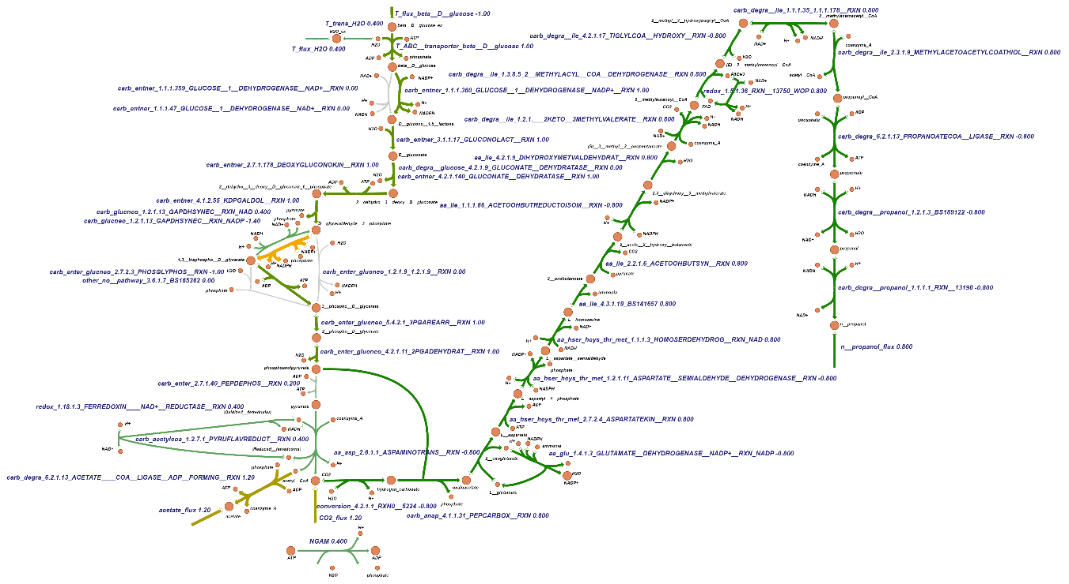

**Figure S2.** The flux of possible fermentation pathways. This flux pattern was obtained by adding the export reactions for all the metabolites, blocking the oxygen import reaction and asking for the generating of ATP. The bound of glucose exchange reaction was fixed at 1 mmol gDW-1 h-1, the NGAM reaction was used as the objective function when running the FBA. The file named “checking 3.1 and 3.2” found in the Github repository under the folder name “codes” showed all the simulations.

We also checked whether there are other electron acceptors such as sulfur or nitrate accessible to the electron transfer chain of *S. solfataricus*. If so, the organism might engage in anaerobic respiration with those electron acceptors to generate a proton motive force and hence ATP. We found that there are no reactions in the GEMM using nitrite as substrate or product. Apart from this we also checked the database KEGG and PATRIC and we did not find any symptoms of this organism being able to use nitrite as electron acceptor. There is only one reaction involving nitrate, which is a nitrate transport reaction. Neither NO nor N2O exist in the map.

Besides nitrate and oxygen, some organisms, such as archaeoglobus (Vetriani, 2001), also use sulfate or sulfur as electron acceptor, in what is called sulfur respiration. Sulfur respiration has been proposed to be an ancestral mode of Gibbs energy provision as on early Earth there was no molecular oxygen available: (i) Volcanic S0 was probably one of the most abundant electron acceptors in the early atmosphere, and (ii) the capacity to reduce S0 to H2S is common among anaerobic, hyperthermophilic Archaea and Bacteria (Vetriani, 2001). Therefore, whether *S. solataricus* can use sulfate as electron acceptor when acquiring free energy is an attractive question.

Then we checked the midpoint potential of the sulfur-sulfide redox couple, sulfite-sulphide couple and sulfate-sulfite couple. The sulfur-sulfide redox couple has an apparent midpoint potential (Eo’; pH7) of -0.27 V, the sulfite-sulphide couple one of -0.12 V whereas the sulfate-sulfite couple has one of -0.52 V (Thauer et al., 1977) suggesting the *S. solfataricus* could harvest Gibbs energy by using sulfite as electron donor to reduce sulfur thereby producing sulfate and sulfide and harvesting some 2.5 kJ/mol electrons. Disproportionation of sulfite to sulfate and sulfide would even yield 4 kJ/mol electrons. We checked whether the metabolic map of *S. solfataricus* has entry/exit points for sulfite, sulfide or sulfate and found that only sulfate and sulfite entry exist as reactions in the map. Then we checked whether the reactions for sulfate reduction exist in the map. Before sulfate can be used as electron acceptor, it must be activated by ATP sulfurylase which uses ATP and sulfate to produce adenosine-5-phosphosulfate (APS). We did find the reactions in the map which can catalyze the reactions from sulfate to sulfide (Figure S3). Then we ran FBA again with the oxygen import reaction blocked and ATP maintenance reaction as objective reaction, but we found there was no production of ATP.

All these clues suggest that there are no alternative respiration pathways that might enable fermentation with positive ATP yield. The experimental observation that *S. solfataricus* is obligate aerobe, is herewith understood on the basis of its genome sequence.

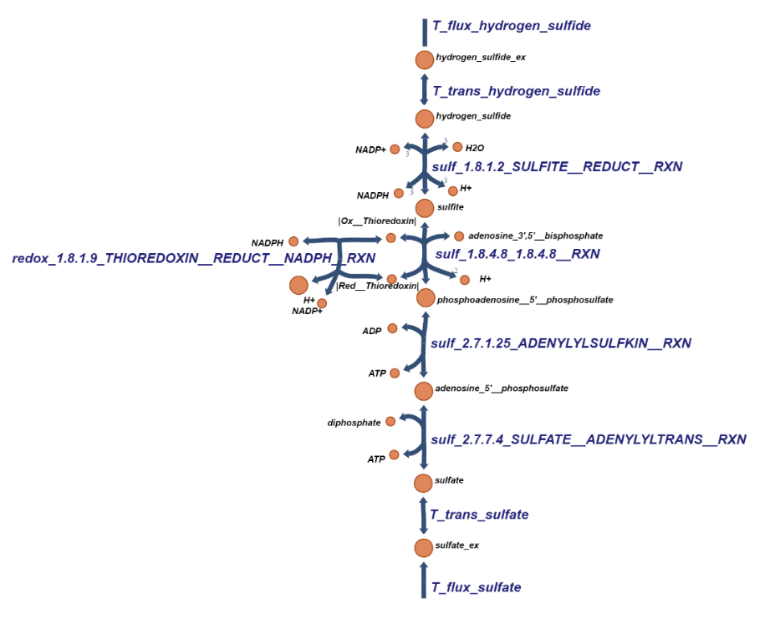

**Figure S3**. Pathway from sulfate to sulfide in *S. solfataricus*. This figure was drawn by the Escher software.

*3.3. Prospective fermentation pathways in S. solfataricus, at various cost*

Since fermentation products are of general biotechnological interest, we examined whether fermentation became possible if an ATP source reaction was added and how much ATP per glucose it should then cost to perform the fermentation. This reaction was furnished with equal upper and lower bounds at a magnitude *n* times the glucose uptake flux bound, with *n* a parameter we could set. Making the fermentation flux through the lactate dehydrogenase reaction the objective, we scanned through multiple values of *n*, thereby asking for prospective fermentation pathways in *S. solfataricus* at various cost. As expected from the preceding section, there were no solutions for negative values of n. The ‘cheapest’ solution (i.e. the solution with the lowest value of *n*) was obtained at *n*=0, with the flux pattern shown in Figure S4A (we had set the maintenance reaction to zero). In this flux pattern ATP was produced at two locations, i.e. the PGK reaction and the PK reaction. We identify this as the dual phosphorylative pathway.

In large metabolic networks, it is often possible for more than one solution to lead to the same desired optimal phenotype. For instance, an organism may have two redundant pathways that both generate the same amount of ATP, so that either pathway could be used when maximum ATP production is the desired phenotype (Orth, Jeffrey D., Ines Thiele, 2010). In order to find flux patterns using other enzymes than PGK or PK to produce the ATP, we blocked either of these reactions and again asked for lactate production at *n*=0. No solution was then produced by FBA. We then scanned all reactions in the existing n=0 solution for ones that had a significant flux and then blocked these one by one, asking for an FBA solution. We found no other alternative solutions which means that when *n* = 0 there are no reactions that can produce ATP besides PGK and PK reaction.

From the perspective of gear shifting we were also interested in more ‘expensive’ flux patterns, ‘expensive’ in terms of Gibbs energy quanta (ATP). In order to find these patterns, we systematically blocked, one by one, the reactions producing ATP in the *n*=0 solution, i.e. PGK and PK (Figure S4A). When blocking PGK, we found no fermentation to lactate until *n* had been increased to 1, confirming that PGK was essential for ATP production. This n=1 flux pattern (the ‘1,3-bisphosphoglycerate spontaneous degradation pathway, Figure S4B) uses the spontaneous degradation reaction of BPG to 3PG instead of the PGK reaction. After finding this solution at n=1, we examined whether a second solution still without using PGK and at n=1 could be found by blocking ATP consuming reactions in the flux pattern of Figure S4B. In Figure S4B, there are two reactions consuming ATP: the KDGK catalyzed reaction and the glucose import reaction. We first blocked both the glucose transport reaction and PGK and found no solution. Then we blocked both the KDGK catalyzed reaction and PGK to find the flux pattern of Figure S4C (Non-phosphorylation pathway). In the flux pattern of Figure S4C, GK is the only ATP consuming reaction besides the ABC transport of glucose. Indeed, when we blocked both GK and PGK, the flux pattern of Figure S4B (the ‘1,3-bisphosphoglycerate spontaneous degradation pathway’) was found again. More systematically, each step with flux higher than 0 in the solution of Figure S4B was blocked in its turn and FBA was used with production of lactic acid as objective, still at *n*=1. In this manner one more solution was found for n=1, as illustrated by Figure S4D (the ‘GAPN pathway’). The equivalence of the solutions Figure S4B and Figure S4D is clear: the one uses GAPN, whilst the other uses GAPDH plus the spontaneous hydrolysis of 1,3-bisphosphoglycerate.

When blocking PK we found no fermentation flux until *n* had been increased to 1. This n=1 flux pattern (Figure S4E) bypassed the PK reaction by using the PEP carboxylase and PEP synthase catalyzed reactions. More systematically, we blocked each step in that solution in its turn, and we found yet another solution (Figure S4E1). This fermentation’s flux pattern involved the production of 3PG through the GAPDH - PGK pathway as well as the reactions catalyzed by 3PG dehydrogenase, phosphoserine aminotransferase, cystathionine-beta-synthase and cystathionine-beta-lyase from 3PG to pyruvate. As in this solution the reactions converting 3PG to pyruvate are not familiar min terms of this function, we checked for the existence of these enzymes both at the genome level and at the RNA level. We found that except for cystathionine-beta-lyase (catalyzing the production of pyruvate from cystathionine), all these enzymes are encoded by the genome and are expressed (These can be found in the file named “reaction_id_RAS” in the Github repository under the folder name “data” ). Although cysthathionine–beta-lyase does not occur in the annotated *S. solfataricus* genome sequence, there is another enzyme called serine dehydratase that can catalyze the production of pyruvate from serine. Therefore, we added the serine dehydratase reaction to, and removed the reaction catalyzed by cystathionine–beta-lyase from, the map and ran the FBA again, yielding the fermentation flux pattern leading to lactate as shown in Figure S4F.

When blocking both the PGK and the PK reactions, we found no fermentation flux until *n* had been increased to 2. Then there were in total 6 equivalent flux patterns. One pattern is shown in Figure S4G. Just like the flux in Figure S4B it uses the 1,3-bisphosphoglycerate spontaneous degradation to bypass the PGK reaction. The difference is that it bypasses the PK reaction by using the PEP carboxylase and PEP synthase catalyzed reactions. When the PEP carboxylase catalyzed reaction was blocked, another flux pattern Figure S4H was found, which also used the spontaneous degradation of 1,3-bisphosphoglycerate, but bypassed the PK reaction using the 3 phosphoglycerate dehydrogenase, phosphoserine phosphatase, phosphoserine aminotransferase and serine ammonia lyase catalyzed reactions. When we blocked the KDGK-catalyzed reaction, the flux pattern of Figure S4I was found, which is similar to the non-phosphorylation pathway, the only difference being that in this flux pattern the PK reaction was bypassed by the PEP carboxylase and PEP synthase catalyzed reactions. By blocking both the KDGK-catalyzed reaction and the PEP carboxylase catalyzed reaction, the flux pattern Figure S4J was found. When the GK catalyzed reaction was blocked, the flux patterns of Figure S4H appeared again. We therefore blocked both the GK catalyzed reaction and the spontaneous degradation of 1,3-bisphosphoglycerate. Then the flux patterns of Figure S4K and Figure S4L were found. Both these flux patterns used the GPAN reaction, thereby bypassing the GAPDH and PGK reactions, but they used different pathways to bypass the PK reaction. We conclude that in addition to the energetically most favorable pathway, there are feasible pathways at lower (negative) ATP per lactate stoicheiometries. Here in total we found 12 possible fermentation pathways to from glucose to lactate. The file named “checking 3.3” found in the Github repository under the folder name “Codes” showed all the simulations.

*3.4. Dual objectives and gear shifting*

Figure S2 illustrates the phenomenon that catabolism might serve more than one objective. One is the generation of a maximum fermentation flux and the other the production of as much ATP as possible. The dual phosphorylation pathway would seem to serve the latter objective best with the highest ATP/pyruvate ratio (at a value of zero). The non-phosphorylative pathway does not serve that same objective. From our analyses it is not quite obvious however that the non-phosphorylative pathway instead serves the other objective of the maximum possible pyruvate flux best.

FBA is often used to optimize the flux distribution over a network towards a single objective. This may be done under constraints, such as maximum flux bounds, a minimum use of reaction rates, enzyme amounts or mitochondrial or ribosomal capacity (H. V. Westerhoff et al., 2009) (Molenaar et al., 2009)(M. J. A. van Hoek & Merks, 2012). Provided the redox coenzymes are treated explicitly, the constraint of a redox balance is in FBA already taken care of via its steady state constraint. But this is not the same as serving two objectives.

FBA can also optimize towards a combined objective however; it optimizes for f = cTv. f may have in it both the fermentation flux (say v1) and the ATP hydrolysis flux, say v2, and with cT = (1, α) FBA optimizes by maximizing fermentation flux if α=0 and it optimizes by maximizing ATP production flux if α is large.

We shall illustrate this procedure for a small part of the network (from GAP to pyruvate), which by itself has a positive ATP yield (Figure S2A). This is the reverse of the reaction:

Pyruvate + NAD+ + n ATP --> GAP + NADH + H+ + n ADP

For various values of *n* we again performed MTA, i.e. FBA with the reverse of the reaction of interest (i.e. with the reaction as formulated above) as the objective. All reactions were bounded at 10, except for the reactions catalyzed by pyruvate kinase and GAPN, which were bounded at 1.

The full line in Figure 1 shows the flux between GAP and 3PG that ran through GAPN; the dotted line shows the flux that ran through GAPDH. In Figure 1A, for *n*<1 or *n*>2 no steady state flux patterns were found (i.e. the FBA algorithm produced no solution). Figure 1A shows that at *n*=1 a solution was produced by the algorithm, in which the flux through GAPN equaled 1.

With *n* increasing beyond 1, this flux dropped linearly to zero, whilst the flux through GAPDH increased linearly with *n* to the value of 1 at *n*=2. This shows that depending on the ATP requirement relative to pyruvate requirement, the optimal pattern should shift from GAPN to GAPDH; by shifting between the two pathways the organism would shift gears in terms of thermodynamically moving more uphill, i.e. synthesize more ATP.

It might seem that the organism should always go for the GAPDH route: this would maximize ATP production whilst not necessarily decreasing the rate of pyruvate production. How would it ‘know’ about a stoichiometry *n* being set at some low rather than high level? More ATP should always be better, shouldn’t it? Well, perhaps it should not; if the cell were not consuming a sufficient amount of ATP in biosynthetic reactions or in maintenance, there might actually be a surplus of ATP. This has been shown to result in ‘overflow metabolism’ (M. J. A. van Hoek & Merks, 2012). We simulated this phenomenon for the same network, now not using the task reaction above but just a maintenance reaction consisting of the hydrolysis of ATP. We then again plotted the fluxes through GAPN and GAPDH as a function of the lower bound of this maintenance reaction whilst optimizing for fermentation flux, again setting the bounds of all other reactions bounds from -10 to 10 except for the GAPN reaction of which the bounds were adjusted from 0 to 1 and the pyruvate kinase reaction which we set to a bound of 1. The resulting Figure 1B shows that at low values of the ATPase bound, the flux followed the GAPN route and only when the capacity of that route ran out, it also invoked the GAPDH route. This illustrates that making more ATP should *not* always be better, as it might not produce a steady state.

Figure 1C shows the result of the same calculations for the case where the bound to the GAP exchange in the model, was set to 1.5, i.e. enough to meet full flux through GAPN but then only half the maximum flux through GAPDH. We also equated the lower bound of the ATPase flux to the upper bound thereby enforcing precise values for this flux. In this case, we found that at high ATPase flux bounds the GAPN flux was reduced in favor of the GAPDH flux.

These calculations show the phenomenon we call ‘gear shifting’, i.e. that depending on the requirement of ATP in anabolism or maintenance, the organism might shift between pathways at different yield of ATP but with the same carbon substrate and product. Overflow metabolism is somewhat different: it combines this aspect of gear with an alteration in catabolic product. The file named “checking 3.3” found in the Github repository under the folder name “Codes” showed all the simulations.



**Figure 1.** Optimal shift patterns between GAPN and GAPDH for a small part of network (from GAP to pyruvate) depending on the ATP requirement relative to pyruvate requirement. (**A**) The shift between GAPDH and GAPN with variation of *n* (*n* is the requested production of ATP per pyruvate); obtained by FBA with the inverse reaction (see text) as objective. (**B**) The shift between GAPDH and GAPN with increase of ATPase (‘maintenance’) reaction flux (upper bound) when the GAP exchange reaction flux was set to 1; FBA with production of pyruvate as objective; ATPase flux was equal to the upper bound of the ATPase reaction. (**C**) The shift between GAPDH and GAPN with increase of ATPase reaction flux when the GAP exchange reaction flux was set to 1.5 in the import direction. The black full line shows the flux between GAP and 3PGA that ran through GAPN and the red dotted line the flux than ran through GAPDH. A negative GAPDH flux means a flux from 1,3bisPGA to GAP.

*3.5. The thermodynamics of gear shifting; variable stoichiometry*

From the thermodynamic point of view, growth is driven by the Gibbs energy of catabolism (∆Gc>0 by our convention; defined as chemical potential difference of substrates minus products). In catabolism this Gibbs energy is partly converted to Gibbs energy in ATP (relative to ADP and phosphate; called (∆Gp>0), whilst the rest is dissipated. This dissipation keeps the processes running at a high rate (Westerhoff & Van Dam, 1987). In anabolism, the ATP Gibbs energy is in part converted to Gibbs energy in biomass (∆Ga; positive for uphill growth). We first consider a single catabolic reaction coupled to the synthesis of n1 molecules of ATP and write for the dependence of its flux () on the two relevant Gibbs energies:

, with the ‘force ratio’ X representing the ratio of the Gibbs energy of ATP synthesis to the Gibbs energy of catabolism:

We use linear (and even proportional) relations in this description, which is only an approximation of reality (Westerhoff & Van Dam, 1987). Our analysis will thereby only be able to illustrate tendencies in the behavior of the system. The number of ATP synthesized per unit catabolic process is denoted by stoichiometry *n1*, and the catalytic capacity *L1* is written as fraction of a total catalytic capacity *L*. The expression shows that at high counteracting Gibbs energy of ATP synthesis (∆Gp), the rate of catabolism should be expected to decrease, a phenomenon related to ‘respiratory control’. The flux of ATP synthesis () , which is driven by is larger by a factor *n1*:

In order to allow shifts between different pathways making ATP, we introduce a parallel pathway, again perfectly coupled to ATP synthesis:

The fraction serves to indicate that this second pathway takes the remaining part of the total catalytic capacity:

The activity of the n2 pathway is herewith assumed to be *ϕ*/(1-*ϕ*) times higher than the capacity for the former pathway. With the weighted-average stoichiometry defined by:

the total catabolic and anabolic fluxes become:

Here we have defined the, now variable, ‘flux-ratio stoichiometry’ by:

This flux-ratio stoichiometry is indeed a function of the force ratio:

For an example where the two stoichiometries equal 0 and 1 respectively, the equation shows that the stoichiometry should decrease with increasing X. This corresponds to phenomenon of automatically diverting flux to the lower gear pathway when confronted with more uphill thermodynamics:

The green line in Figure S5 shows the predicted dependence of the stoichiometry on the force ratio X for a different example. This variation of the stoichiometry with the force ratio derives from the phenomenon that with increasing force ratio, a smaller and smaller fraction of the phosphorylation flux flows through the high stoichiometry pathway (see Figure S5). In parallel both the total ATP synthesis flux and well as the thermodynamic efficiency of the process decrease. The latter is defined by:

Both the stoichiometry and the efficiency cross zero at a force ratio of around 0.75. At this force ratio the system is ‘stalling’, wasting Gibbs energy of catabolism whilst making no progress towards ATP synthesis.

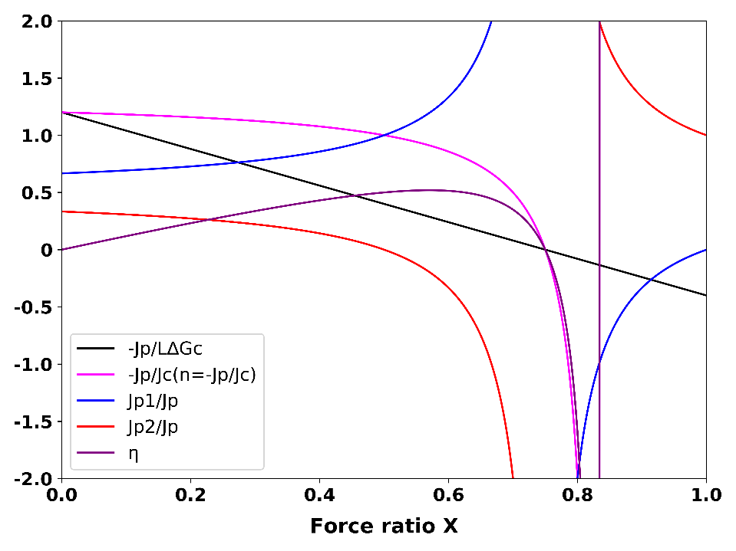

**Figure S5.** Dependence of ATP synthesis flux, overall flux ratio, flux ratios through the two branches, variable stoichiometry (n=-Jp/Jc), and thermodynamic efficiency on the counteracting force ratio. Results of computations for two parallel catabolic pathways with φ=0.2, n1=1, n2=2. The equation was used for simulation of as function of force ratio X; The equation was used for calculation of -Jp/ Jc; The equation / was used for calculation of –Jp1/Jp; The formula / was used for calculation of –Jp2/Jp; The equation was used for simulation of as function of force ratio X. At a force ratio of 0.75 the output flux of ATP synthesis reverts to ATP degradation, while catabolism continues. This corresponds to a car still using gasoline to try to move forward but beings force back downward due to gravity. Consequently, the stoichiometry and the thermos dynamic efficiency becomes negative. Only at the force ratio of 0.83 also catabolism inverts. At this and higher force ratios, the model simulates reverse operation where ATP hydrolysis would drive reversal of catabolism, which is not often realistic. The file named “figures” under the folder of “Codes” in the Github repository showed how this figure can be obtained.

*3.6. Variable coupling*

ATP synthesis and catabolism are coupled to each other. This coupling has two aspects. First, at more intensive coupling the ratio of the ATP synthesis flux () to the catabolic flux () should increase. Second with more intensive coupling the catabolic flux should feel a stronger ‘backpressure’ by the Gibbs energy of ATP synthesis. This is expressed by the effect of the degree of coupling *q* in the following two equations (Kedem & Caplan, 1965):

*Z*>0, *q*>0, *L*>0, and X>0 represent the phenomenological stoichiometry, the degree of coupling, the catalytic capacity of catabolism, and the ratio of the counteracting Gibbs energy of anabolism to the driving Gibbs energy of catabolism, respectively. This expression does not describe reality precisely (reality is more nonlinear than this; Westerhoff & Van Dam, 1987), but it may still serve to illustrate qualitatively the roles played by the (Gibbs) energy, the phenomenon of ‘coupling’, stoichiometry, catalytic activity and the thermodynamic ‘forces’. The equations show that if per unit catabolic process more ATP is made (partly reflected by an increase in the so-called, phenomenological stoichiometry), both the backpressure effect and the flux ratio should increase. Stronger coupling and increased such stoichiometry Z have opposite effects on the excess thermodynamic force through which catabolism drives ATP synthesis; the former increases and the latter decreases this.

When mapping these phenomenological equations onto our earlier equations describing our system of two parallel pathways making ATP, we find for the phenomenological stoichiometry Z a special weighted average of the stoichiometries of the two pathways:

Notably, the phenomenomological stoichiometry does not equal the flux ratio

Also the degree of coupling q depends on the stoichiometries of the two pathways as well as on their relative activities, but in a different way:

If there is complete coupling, then q=1 and Z always equals the ratio of growth rate to catabolic flux. Then Z functions as a true, i.e. constant stoichiometry. If the fraction equals zero or 1, i.e. if only pathway 1 or pathway 2 is active, the degree of coupling equals 1, and the phenomenological stoichiometry equals the stoichiometry of the pathway that is active. For in between 0 and 1, the phenomenological stoichiometry lies in between those of the two pathways, but the degree of coupling is lower than 1, showing that the gear shifting is accompanied by uncoupling. This reflects the possibility that at some force ratios the one pathway synthesizes ATP whilst the other operates in reverse mode and hydrolyzes the same amount of ATP. Net catabolism is then incompletely coupled to the net synthesis of ATP. Z does not vary with the force ratio X.

More generally, the equations reflect that growth rate should be expected to increase with (i) the magnitude of the Gibbs energy of catabolism (which is therefore called the driving force for growth), (ii) the catalytic capacity of catabolism *L*, (iii) the degree of coupling *q* (i.e. if there is less ATP diverted to maintenance or proton leakage and the coupling thereby increases, the growth rate should go up as well). On the other hand the growth rate should decrease (iv) with increasing back pressure from a higher Gibbs energy of growth ().

*3.7. Variations in the phenomenological stoichiometry could improve ATP synthesis and growth*

Various authors have considered the variation of the output flux (here ATP synthesis *–Jp* or growth rate *-Ja*), yield (-*Ja/Jc),* and thermodynamic efficiency () with the Gibbs energy (‘force’) ratio . They did this for degrees of coupling equal to or smaller than 1 and then found that in the latter case the ratio of output flux to input flux decreased from Z to zero with increasing counteracting force ratio X, whilst Z was constant. This is concordant with the curve shown for in Figure S5.

Stucki also considered the dependence of the performance of mitochondrial oxidative phosphorylation on the degree of coupling q (Stucki, 1980). He considered the possibility of dual optimization, consisting of adjustments of both the force ratio X and the degree of coupling q so as to obtain optimality in terms of two rather than one criteria. This seemed to explain incomplete coupling in mammalian mitochondria (Stucki, 1980). It led to the concept that microbial growth may be optimized for both efficiency and growth rate (Westerhoff and Van Dam, 1987).

Little attention has been paid to dependencies on the stoichiometry Z: being a stoichiometry, Z was considered immutable. In this paper we break with this tradition and focus on variations of Z and subsequently on the, related, variations of *n(X)*, which we shall call ‘gear shifting’. Figure S6 shows how for four pathways with different values of the phenomenological stoichiometry Z buts the same degree of coupling q, the ATP synthesis flux varies with the counteracting force ratio X. At low counteracting force ratio the pathway with the highest stoichiometry makes most ATP, but with increasing force ratio its ATP synthesis flux decreases strongly, more so than for pathways with lower stoichiometries. At a force ratio of 0.15, the ATP synthesis by the pathway with phenomenological stoichiometry of 4, dives below the ATP synthesis of the pathway with a stoichiometry of 2. The green line in Figure S6 shows that at force ratios below 0.29, having the four pathways operate in parallel is better than just operating one of them individually. In that range of force ratios, an ‘automatic’ tendency for the network to run flux through lower stoichiometry pathways, helps to keep the total flux of ATP synthesis high. At force ratios above 0.3 however, the network with all four pathways operative in parallel, turns to dismal performance due to the phenomenon that the pathway with the highest stoichiometry inverts its ATP synthesis flux into ATP hydrolysis. A futile, ATP hydrolyzing cycle hereby appears.

It should be better for the ATP synthesis if at the higher force ratios the pathway would switch between pathways, activating lower stoichiometry pathways whilst inactivating high stoichiometry pathways. At fixed values of X and q, the ATP synthesis flux is a parabolic function of the phenomenological stoichiometry Z with a maximum at:

, confirming that at small force ratios, increasing Z should enhance ATP synthesis, but not at high force ratios. Assuming that a regulatory network sets Z to this optimal value for each force ratio, the ATP synthesis flux should be given by:

The dashed purple line in Figure S6 shows that indeed, such a ‘variomatic regulation’ of Z should produce a higher ATP synthesis flux than any other individual pathway with fixed settings of Z.

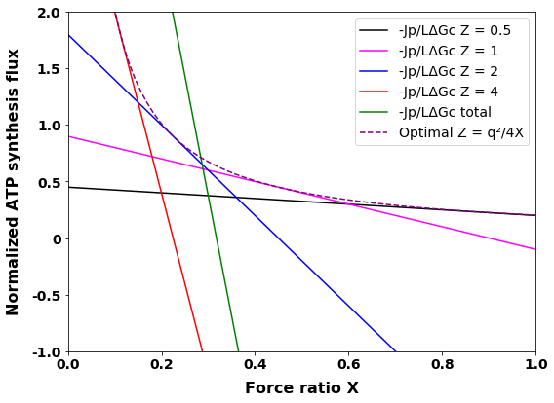

**Figure S6.** Variomatic gear shifting. Normalized ATP synthesis flux versus force ratio at four magnitudes of the phenomenological stoichiometry Z, as well as their sum total and ATP synthesis for optimal ‘variomatic gear shifting’ and maximal ATP synthesis flux. The equation was used for simulation of as function of force ratio X. In these simulations, q=0.9 and various values of Z (0.5, 1, 2, 4) were used. The file named “figures” under the folder of “Codes” in the Github repository showed how this figure can be obtained.

*3.8. Gear shifting and varied stoichiometries could improve ATP synthesis and growth*

In the above we considered situations of different phenomenological stoichiometries at the same value of the coupling coefficient q. When gear shifting by changing the catalytic capacities of pathways with different stoichiometries, i.e. when gear shifting by changing the factor φ, one most often also changes the degree of coupling. Figure S7 plots the ATP synthesis flux versus the force ratio for various magnitudes of φ, at fixed magnitudes of the ATP stoichiometries n1 and n2 of the two pathways. Again, at low force ratios, the higher stoichiometry pathway produced more ATP synthesis than lower stoichiometry pathways, but at high force ratios (X>0.25) this inverted. Now however, as opposed to Fig. S6 in which the degree of coupling was held the same for the different values of Z, all the lines intersect at a single point, implying that, if the degree of coupling were allowed to vary, it would make no sense gradually to shift to lower stoichiometry with increasing force ratio. At one critical force ratio it should be best to switch immediately from the highest to the lowest stoichiometry pathway (Figure S7). A corollary would be that there be no evolutionary advantage to having multiple pathways with multiple stoichiometries, such as we found through analysis of the metabolic map of in *S. solfataricus*. Two different stoichiometries should do.

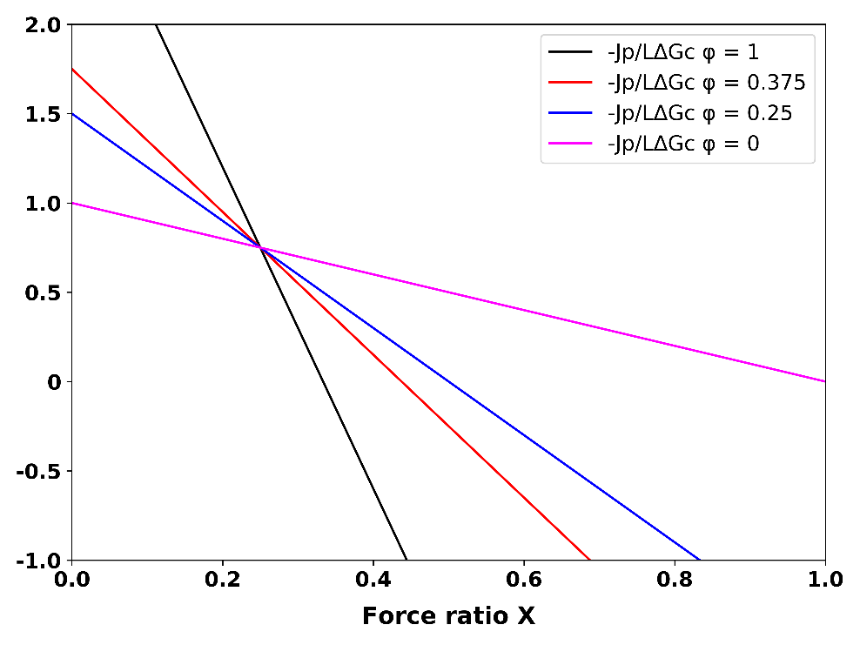

**Figure S7.** Simulated ATP synthesis flow as function of force ratio at various relative pathway capacities. In these simulations both Z and q were varied as a function of φ, which was kept constant while X was varied. The equationwas used for simulation of as function of force ratio X. In these simulations, n1=1 and n2=3, various values of φ (1, 0.375, 0.25 and 0) were used. The file named “figures” under the folder of “Codes” in the Github repository showed how this figure can be obtained.

Above we showed that if two pathways take over the role of a single pathway, this has the effect of introducing a variable stoichiometry n(X). From this we infer that having multiple pathways should enable an organism effectively to regulate its pathway stoichiometry. Figure S8 therefore shows the variation of the flux of ATP synthesis with the force ratio for four values of the stoichiometry n. Again the ATP synthesis flux is best for high stoichiometry at low X and for low stoichiometry at high X. As when we varied the phenomenological stoichiometry at constant degree of coupling, the lines do not all intersect at a single point. The implication is that it should make sense for the cells to shift their stoichiometries from 4 to 3, to 2 and then 1 as indicated by the line labelled ‘gear’ in the figure. The organism should do this by activating one pathway and suppressing all the others, again to prevent futile cycling. The system corresponds to ‘automatic discontinuous gear shifting’ between integer gears settings.

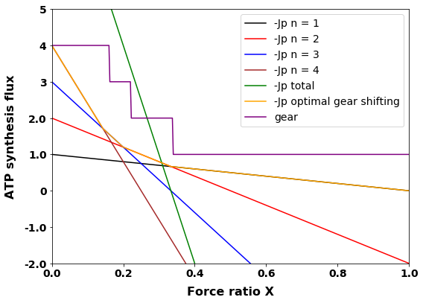

**Figure S8.** Automatic discontinuous gear shifting. ATP synthesis as function of counteracting force ratio for 4 different stoichiometries, all together, as well as the optimal gear shifting case with the corresponding gear settings. The equationwas used for simulation of as function of force ratio X. In these simulations, n1, n2, n3 and n4 were taken equal to 1, 2, 3 and 4, = 0, *L*= 1, *∆Gc* = 1. Jp total is the sum of the four Jp’s. The purple line (consisting of four smaller straight lines at angles with each other) represents the effect of operating always (i.e. at any force ratio X) only a single one of the four gears, i.e. the one with the highest flux of ATP synthesis. The difference of the optimal gear setting with that of Figure S6 is that the shifting is not continuous but only between integer values of Z as shown by the lines labelled ‘gear’. The file named “figures” under the folder of “Codes” in the Github repository showed how this figure can be obtained.

*3.9 Kinetic model demonstrating gear shifting in S. solfataricus*

In the preceding sections, we used a non-equilibrium thermodynamic description to illustrate the principles of gear shifting. We changed the phenomenological stoichiometry Z. The linear non-equilibrium thermodynamic description of bioenergetics is able to predict and describe the features of the process only qualitatively, as the linear flow force relations used are only strictly valid close to equilibrium. It should be more accurate to describe the effects of such gear shifting when using validated enzyme kinetic descriptions of the process, especially if these have been validated at least in part, experimentally. In this section we shall therefore implement a kinetic model to possible gear shifting in a set of processes where a validated model description is available: this is the lower half of glycolysis in *S. solfataricus*, where there could be shifting between GAPDH plus PHK and GAPN.

The shift from the GAPDH route to the GAPN route at low ATP consumption flux by anabolism and maintenance, as produced by the FBA computation above, was caused by the FBA requirement that ATP should be at steady state. Should fermentation persist in the GAPDH route, the amount of ATP produced would be higher than could be degraded by anabolism and maintenance, and steady state could then not be attained. Cell metabolism does not ‘know’ directly about any such formal requirements however, so what would be the mechanism for the steady state to remain? That mechanism should be the lack of the substrate or the excess product ATP leading to product inhibition or reaction reversal and to the consequent reduction of the rate of the GAPDH reaction. In order to test this idea, we examined whether the gear shifting was also produced by a kinetic model based on experimentally determined parameter values that we previously built for this pathway (Zhang et al 2017).

Generally, there are two different ways to regulate metabolic fluxes. One is ‘hierarchical’ regulation by changes of gene expression that adjust enzyme capacities (Vmax) and the other is ‘‘metabolic’’ regulation by changes in the interactions of enzymes with substrates, products, or allosteric effectors due to changes in concentrations of the metabolites (ter Kuile & Westerhoff, 2001). Here the mathematical model of (Zhang et al., 2017) is used for demonstrating the ‘metabolic’ part of the regulation of the pathway flux towards maintaining steady state. As we did not have all the kinetic parameters for a sufficient number of other reactions in the network, we simulated only the pathway from GAP to pyruvate (Figure 2A). This simulation (Figure 2B and Figure 2C) shows that on the basis of the kinetic parameters known, the ATP/ADP ratio was indeed a strong determinant of the fluxes through the GAPDH plus PGK pathway and the GAPDH pathway. With the increase of ATP/ADP value, the flux of GAPDH decreased, whilst the flux through GAPN increased monotonically. This embodies the homeostatic regulation of the fluxes that can maintain the steady state. It also corresponds to gear shifting, as the ratio of the two fluxes changes with changes in ‘work load’, i.e. the ATP/ADP ratio. From Figure 2B and Figure 2C we also note that at higher temperature (80 ℃) the fraction of GAPDH plus PGK pathway is more negative when compared with that at lower temperature (70 ℃), which means that the flux for GAPDH plus PGK in the gluconeogenesis direction is even higher. We conclude that the ATP/ADP ratio could well be the force driving the shifting of the organisms from the high-gear GAPDH plus PGK route to the low-gear GAPN when the Gibbs energy becomes too high to allow flux through the former route. A complex feature here is that the former flux is always negative, i.e. in the gluconeogenic direction. Comparison of Fig 2B with Fig. 2C shows that temperature changes can cause gear shifting. The models can be found in the Github repository under the folder name “Models” showed the simulations.



**Figure 2.** The scheme and fraction of various pathway fluxes from GAP to 3PG. (**A**) Scheme of the pathways connecting GAP to pyruvate for *S. solfataricus*; lines with single arrow heads refer to reactions considered irreversible; the red dashed line refers to spontaneous (i.e. not enzyme catalyzed) hydrolysis of BPG to 3PG. (**B**) The fraction of the flux from GAP to Pyr running through GAPDH (GAPN) at 70 ℃; (**C**) The fraction of the flux from GADPH to Pyr flux running through GAPDH (GAPN) at 80 ℃. The fluxes were computed using the kinetic model (Zhang et al., 2017) for various magnitudes of the rate constant for ATP hydrolysis and plotted versus the ATP/ADP ratio calculated. The Vmax’s in the rate law for the different reactions were changed according to Table 6 except for the Vmax for the ENO reaction (The Vmax for ENO reaction has not been measured, so we just kept value in the earlier model). In these models the concentrations of GAP, Pyr, NADP, NADPH, phosphate were fixed at 0.15, 1.85, 1.2, 0.39, and 10 mM, respectively. A negative fraction for the GAPDH flux reflects that this flux runs in the gluconeogenic direction (i.e. from 3PG to GAP).

*3.10.* *The shifting between the different ‘fermentation pathways’ during aerobic carbon and energy metabolism*

In section 3.3 we reported that when oxygen is depleted there are 12 prospective fermentation pathways at various cost of ATP. Downstream of pyruvate there is the pyruvate dehydrogenase complex, the TCA cycle and oxidative phosphorylation with NADH and succinate as reductants and molecular oxygen as oxidant.

Three terminal oxidases may exist in *S. solfataricus*: SoxABCD, SoxM and DoxABCDE (Figure 3). The SoxABCD complex was proven to be a proton-pumping quinol oxidase in *S. acidocaldaricus* (Gleißner et al., 1997). The SoxABCD complex of *S. solfataricus* was described as a proton-pumping quinol oxidase because of its strong homology with that SoxABCD complex of *S. acidocaldaricus* (Lübben et al., 1994). The SoxABCD complex of *S. solfataricus* is composed of a subunit II (SoxA, sso2658), a cytochrome aa3 subunit I (SoxB, sso2657), a cytochrome b subunit (SoxC, sso2656), and an additional cytochrome b subunit (SoxD, sso10828) (Simon et al., 2009). This complex was found to combine features of respiratory complexes III and IV (Schäfer et al., 1999). In this complex the aa3 subunit (a product of the *soxB* gene) alone can function as a quinol oxidase (Anemüller & Schäfer, 1990). This SoxB represents a subunit I equivalent to the typical heme-Cu oxidase; its binuclear center contains two hemes A and one CuB. SoxA, like subunit II in the quinol oxidase of *E.coli*, lacks the typical mixed-valence binuclear CuA centre of cyt c oxidase. Another even larger complex which may also function as quinol oxidase is SoxEFGIM (which is abbreviated as SoxM). In *S. acidocaldaricus* this complex combines features of quinol and cytochrome c oxidase (Komorowski et al., 2005). Since the SoxM complex of *S. solfataricus* has a strong homology to that in *S. acidocaldaricus*, it also thought to have these features. It is a complex of six subunits: sulfocyanin (SoxE, sso2972), Rieske iron-sulfur protein-2 (SoxF, sso2971), cytochrome b (SoxG, sso2970), subunit II (SoxH, sso2969), putative subunit (SoxI, sso2968) and subunit I/III, cytochrome aa3 (SoxM, sso2973) (Simon et al., 2009). This complex may represent a genetic as well as functional fusion of an analog to complex III with a ba3-type terminal oxidase utilizing sulfocyanine instead of cytochrome c (Schäfer et al., 1999). Apart from the SoxABCD complex and the SoxM complex, also the complex called DoxABCDE might function as quinol oxidase. Its homolog in another thermoacidophilic archaeon *Acidianus ambivalens* has been shown to have quinol oxidase activity (Müller et al., 2004).

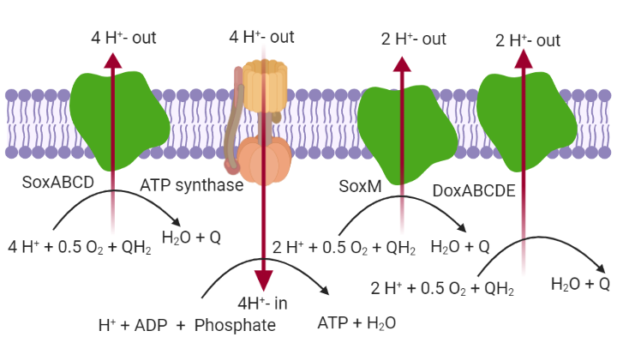

**Figure 3.** The different quinol oxidases in *S. solfataricus*, together with the H+-ATPase (ATP-synthase). This figure was created with BioRender.com. Sox stands for Sulfolobus oxidase, while Dox represents Dioxygen oxidase. H+-out, H+-in, QH2 and Q in the model are written as H+_rc, H+, representative_quinol and representative_quinone, respectively.

The three complexes catalyze similar overall reactions. As the midpoint potential at electron entry differs between them (Schäfer et al., 1999), there are a minor though important differences between the reactions they are reported to catalyze. For SoxM and DoxABCDE the reaction is “ 2 H+ + 0.5 O2 + representative quinol 🡪 2 H+rc + 2 Psi + H2O + representative quinone”, while for SoxABCD it is “4 H+ + 0.5 O2 + representative quinol 🡪 4 H+rc + 4 Psi + H2O + representative quinone”. Accordingly, the oxidases only differ in proton pump stoichiometry with corresponding implications for the ATP production they entail.

When allowing the import of oxygen and blocking the SoxABCD reaction, we found the flux pattern of Figure S9. In this flux pattern, instead of using PGAM and ENO to produce pyruvate, it is using some reactions in the glycine, serine metabolism and sulfopterin metabolism. We checked the RNA expression level of the proteins catalyzing these reactions in the supplementary file “80vs70 ArrayData”. We found that some proteins cannot be expressed. Consequently, in the subsequent simulation we blocked this flux pattern by blocking the reaction catalyzing the conversion of 10 – formyl-tetrahydrosulfopterin to formate.

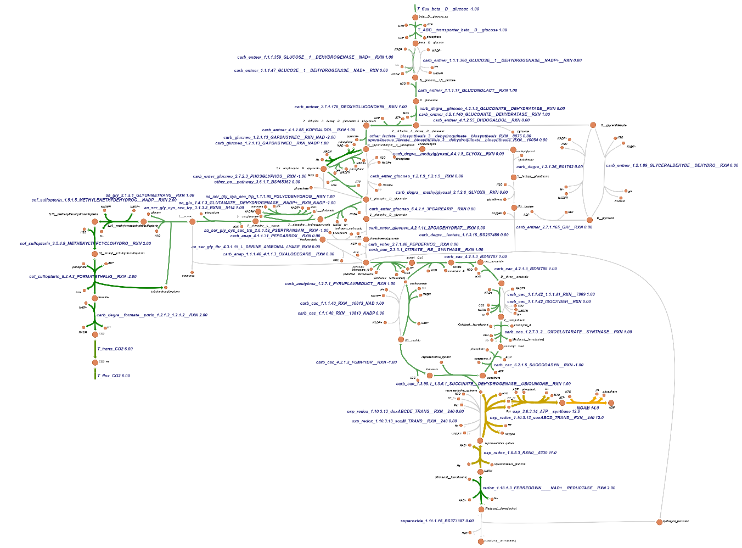

**Figure S9.** The flux pattern when allowing oxygen to be imported. Here, the bound of the glucose import reaction was fixed at 1 mmol gDW-1 h-1, all other bounds at 1000, and the NGAM reaction was used as the objective function when running the FBA. The file named “checking 3.10 ATP” found in the Github repository under the folder name “Codes” showed the simulation.

Table 3 shows that when different pathways or terminal oxidases were used (This was enforced in the FBA by blocking the other two terminal oxidases), the production of ATP was different. Take the first pathway for example, the FBA showed that an ATP/glucose ratio of 14 was obtained for the GAPDH and PGK pathway when using SoxABCD, as follows: (i) 2 ATP obtained at succinyl CoA synthetase, (ii) 6 NADH and 4 reduced ferredoxin pumping 40 protons (There is no classical complex I in the respiratory chains of archaea (Schafer et al., 1996).); these should be leading to 10 ATP through the H+ATPase, (iii) through succinate dehydrogenase 2 representative quinol should be produced which could lead to the pumping of 8 protons, leading to 2 ATP. By using flux balance analysis, we find a diversity of 13 possible flux patterns with 8 different ATP yields.

**Table 3.** The ATP production flux when using different pathways. Maximum glucose uptake flux was taken to be 1 mmol gDW-1 h-1, while allowing the unlimited uptake of oxygen, phosphate, sulfate, ammonium, H+, H2O, Co2+. The flux through the ATP hydrolysis reaction (growth rate independent maintenance; NGAM reaction) was used as the objective function when doing flux balance analysis and the flux through it (relative to the glucose influx) is reported, E.G. ‘6’ means 6 ATP per glucose. In all cases the glucose uptake flux reached its maximum.

|  |  |  |  |  |
| --- | --- | --- | --- | --- |
| Flux pattern number | Pathway name | From 3PG to Pyruvate | If using SoxABCD | If using SoxM (or DoxABCD) |
| 1 | GAPDH plus PGK pathway | Pathway 1 | 14 | 8 |
| 2 | Non-phosphorylation pathway | Pathway 1 | 13 | 7 |
| 3 | GAPDH and spontaneous degradation | Pathway 1 | 13 | 7 |
| 4 | GAPN pathway | Pathway 1 | 13 | 7 |
| 5 | Methylglyoxal pathway | Pathway 1 | 10 | 5 |
| 6 | GAPDH plus PGK pathway | Pathway 2 | 13 | 7 |
| 7 | Non-phosphorylation (GAPN) pathway | Pathway 2 | 12 | 6 |
| 8 | GAPDH and spontaneous degradation | Pathway 2 | 12 | 6 |
| 9 | GAPN pathway | Pathway 2 | 12 | 6 |
| 10 | GAPDH plus PGK pathway | Pathway 3 | 13 | 7 |
| 11 | Non-phosphorylation pathway | Pathway 3 | 12 | 6 |
| 12 | GAPDH and spontaneous degradation | Pathway 3 | 12 | 6 |
| 13 | GAPN pathway | Pathway 3 | 12 | 6 |

Pathway 1: from 3PG to Pyruvate, using phosphoglycerate mutase, enolase and pyruvate kinase catalyzed reactions. Pathway 2: from 3PG to Pyruvate, using phosphoglycerate mutase, enolase, PEP carboxylase and PEP synthase catalyzed reactions. This was obtained by blocking PK and 3-phosphoglycerate dehydrogenase reactions. Pathway 3: from 3PG to Pyruvate, using 3 phosphoglycerate dehydrogenase, phosphoserine phosphatase, phosphoserine aminotransferase and serine ammonia lyase catalyzed reactions. This was done by blocking PK and PEP carboxylase reactions.

When we optimized for the production of biomass (The NGAM flux is then fixed to 1.9 mmol ATP gDW-1h-1, because this value resulted in a carbon usage ratio of 25%, which has been determined in the laboratory (Ulas et al., 2012).), we observed that the different pathways gave different biomass production fluxes (table 4). This show that the biomass production has a strong connection with the energetics: If the pathway can produce more ATP energy, this may lead to higher biomass production.

**Table 4.** The biomass production fluxes of the different pathways. The fluxes start with maximum uptake flux of extracellular glucose at 1 mmol gDW-1 h-1 and with NGAM flux fixed to 1.9 mmol ATP gDW-1h-1, while allowing the unlimited uptake of oxygen, phosphate, sulfate, ammonium, H+, H2O, Co2+. Biomass production reaction was used as the objective reaction in the flux balance analysis. The file named “checking 3.10 biomass” found in the Github repository under the folder name “Codes” showed all the simulations.

|  |  |  |  |  |
| --- | --- | --- | --- | --- |
| Pathway numbers | Pathway names | From 3PG to Pyruvate | SoxABCD Biomas (h-1) | SoxM (or DoxABCD) Biomass (h-1) |
| 1 | GAPDH plus PGK pathway | Pathway 1 | 0.071 | 0.051 |
| 2 | Non-phosphorylation pathway | Pathway 1 | 0.066 | 0.043 |
| 3 | GAPDH and spontaneous degradation | Pathway 1 | 0.066 | 0.043 |
| 4 | GAPN pathway | Pathway 1 | 0.066 | 0.043 |
| 5 | Methylglyoxal pathway | Pathway 1 | 0.052 | 0.028 |
| 6 | GAPDH plus PGK pathway | Pathway 2 | 0.068 | 0.044 |
| 7 | Non-phosphorylation pathway | Pathway 2 | 0.062 | 0.036 |
| 8 | GAPDH and spontaneous degradation | Pathway 2 | 0.062 | 0.036 |
| 9 | GAPN pathway | Pathway 2 | 0.062 | 0.036 |
| 10 | GAPDH plus PGK pathway | Pathway 3 | 0.068 | 0.044 |
| 11 | Non-phosphorylation pathway | Pathway 3 | 0.062 | 0.036 |
| 12 | GAPDH and spontaneous degradation | Pathway 3 | 0.062 | 0.036 |
| 13 | GAPN pathway | Pathway 3 | 0.062 | 0.036 |

An intriguing question is why this organism has maintained SoxM complex or DoxABCD complex in its evolutionary history? The SoxABCD complex seems to be superior as it leads to the pumping of more protons and hence to the synthesis of more ATP, which could then energize more growth. FBA can only give one of the optimized solutions which means that if the objective function is the production of ATP, FBA will never use SoxM complex or DoxABCD complex because using them will pump fewer protons that drive the production of ATP. Yet, both SoxM and DoxABCD are expressed in this organism (We verified this by analyzing the transcriptome; see the supplementary files with the name “80vs70 ArrayData”). Here we introduce a ‘Factor Z’, which represents the gear setting required by anabolism. And we set the upper bound for the Sox M (DoxABCD) catalyzed reaction to 12-Z (Here 12 is the maximum of SoxABCD flux in terms of 2-electron equivalents when glucose importing is 1 mmol gDW-1 h-1) and the upper bound for the SoxABCD catalyzed reaction to Z. For each value of Z we then ran FBA with ATP production as objective function. With this “Factor Z” we can see a shift between SoxABCD and SoxM (or DoxABCD) utilization, and with this shift different amounts of the NGAM flux were obtained in silico. This leds to Table 5, where we can see the potential of the network to shift gears.

**Table 5.** ATP production as a function of the gear setting Z. There are 13 possible gears, i.e. 13 possible settings for Z. Z is taken equal to 12 times the ratio of SoxABCD 2-electron flux to total 2 electron flux. Total flux is SoxABCD flux plus SoxM (or DoxABCD) flux. All calculations used the GAPDH-PGK- PK pathway between GAP and pyruvate. The fluxes start with maximum uptake of extracellular glucose at 1 mmol gDW-1 h-1, while allowing the unlimited uptake of oxygen, phosphate, sulfate, ammonium, H+, H2O, Co2+. The ATP hydrolysis reaction (NGAM) was used as the objective function when doing flux balance analysis whilst setting the upper bound of the SoxABCD at various levels. The unit of this flux is mmol gDW-1 h-1. The file named “checking 3.10 ATP” found in the Github repository under the folder name “Codes” showed all the simulations.

|  |  |  |  |  |
| --- | --- | --- | --- | --- |
| Gear setting Z | SoxABCD flux (in 2-electron equivalents per glucose import) | SoxM (DoxABCD) flux | NGAM (maintenance ATPase) | H+-ATPsynthase proton flux per glucose imported |
| 0 | 0 | 12 | 8 | 24 |
| 1 | 1 | 11 | 8.5 | 26 |
| 2 | 2 | 10 | 9 | 28 |
| 3 | 3 | 9 | 9.5 | 30 |
| 4 | 4 | 8 | 10 | 32 |
| 5 | 5 | 7 | 10.5 | 34 |
| 6 | 6 | 6 | 11 | 36 |
| 7 | 7 | 5 | 11.5 | 38 |
| 8 | 8 | 4 | 12 | 40 |
| 9 | 9 | 3 | 12.5 | 42 |
| 10 | 10 | 2 | 13 | 44 |
| 11 | 11 | 1 | 13.5 | 46 |
| 12 | 12 | 0 | 14 | 48 |

*3.11 Metabolic rewiring*

*3.11.1 Metabolic rewiring as inferred from transcriptome alterations*

By changing gene expression, organisms can rewire their metabolic map, i.e. repress some parts and express others. Temperature is an environmental factor that influences many biological processes. Consequently, life at high temperature requires efficient adaption strategies. In order to investigate temperature adaption strategies, the transcriptome of *S. solfataricus* has been measured by our collaborators (Zaparty et al., 2009) for growth at two different temperatures (70 ℃ and 80 ℃).

By mapping partially the transcriptome data (shown in Table 6) to the model with the ‘α factor’ (The simulations are shown in the Github repository in the file name “Mapping RAS to the bounds of the reactions”under the folder name “Codes”. ) fixed at 100 000 and the bound of the glucose exchange reaction fixed at 1 mmol gDW-1 h-1, the simulation results show that at low temperature (70 ℃) the organism uses the GAPDH-PGK pathway and the non-phosphorylation pathway (Figure S10), while at high temperature (80 ℃) the organism only uses the GAPDH and PGK pathway (Figure S11). Apart from this, there is also a rewiring of terminal oxidases: at lower temperature the SoxABCD reaction carried more flux when compared with that at higher temperature. The maintenance ATPase flux (NGAM) was also lower at higher temperature. This suggests that perhaps due to the lower expression of the SoxABCD complexes at higher temperature, the ATP production flux and levels became more limiting. The organism shifts to lower gears here. Enhanced flux through the other two terminal oxidases and through GAPDH plus PGK (at the cost of flux through the non-phosphorylative pathway through glycerate) may have been a consequence of the FBA attempting to re-increase its objective, the ATP production flux. Apparently the GAPDH and PGK expression levels were high enough to allow this to happen *in silico*. It should be stressed however that these FBA results only show flux potential, not the actual fluxes that would be obtained experimentally.

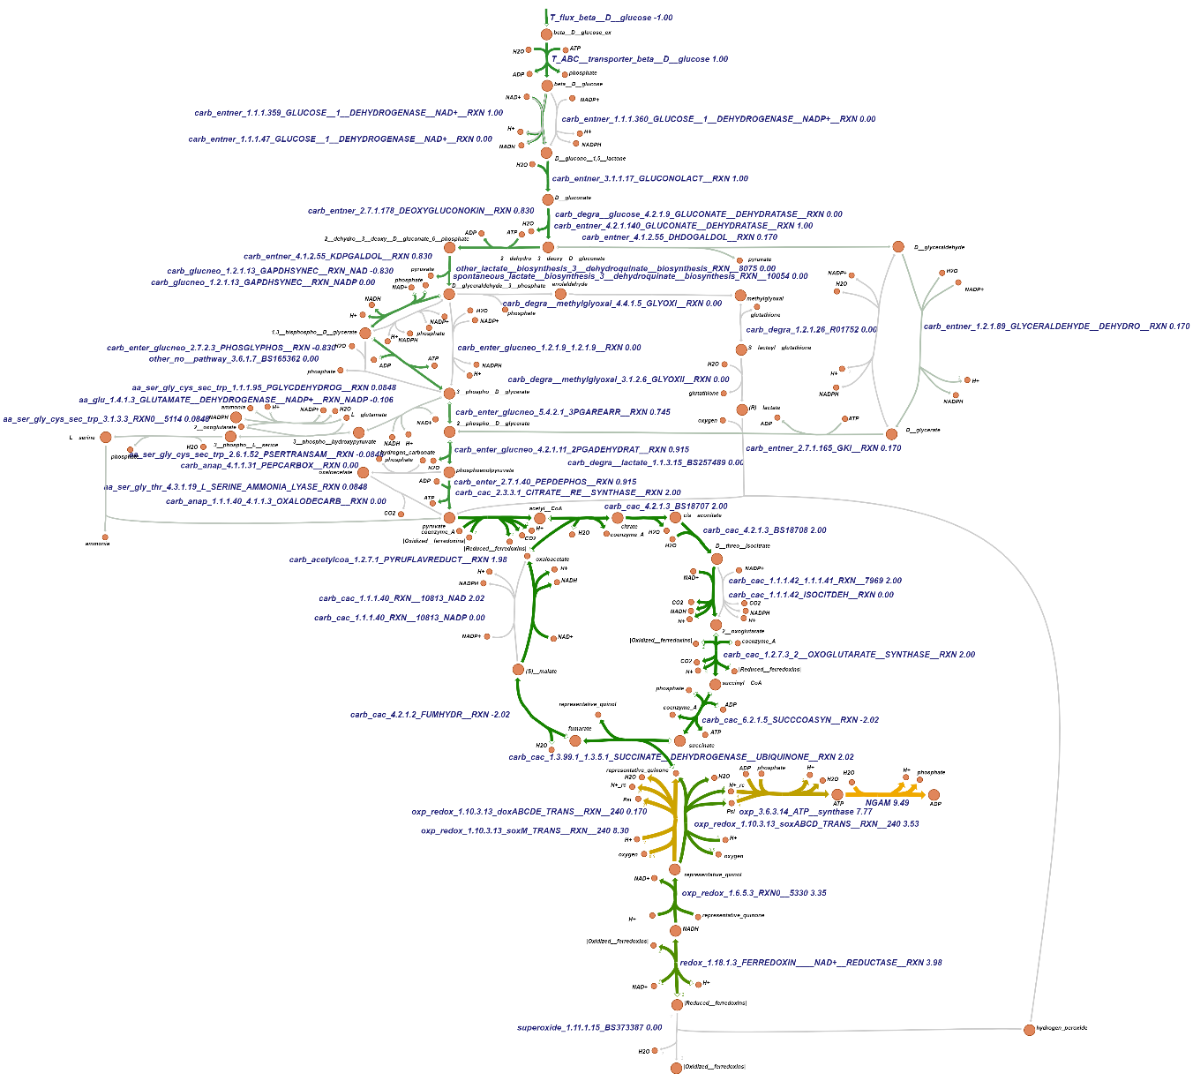

**Figure S10.** The flux distributionspredictedwhenmapping the transcriptomic data for the cells at lower (70° C) temperature to the genome wide metabolic map. Here the α factor was fixed at 100 000 and the bound of the glucose exchange reaction fixed at an inward flux of 1 mmol gDW-1 h-1. The NGAM reaction was used as the objective function for running FBA.

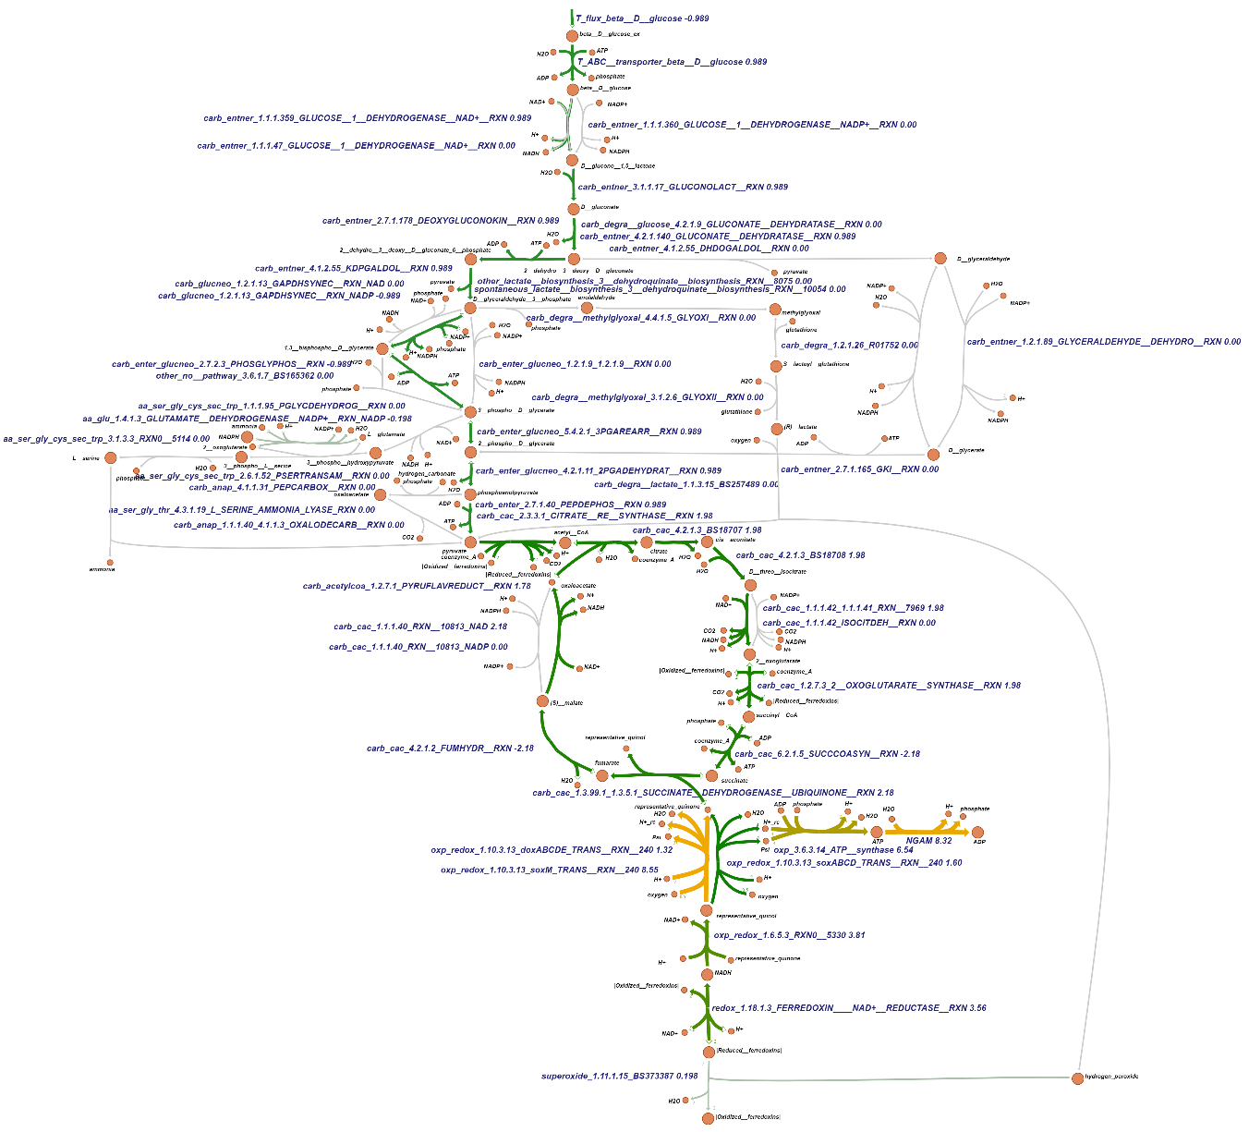

**Figure S11.** The flux distributionswhenmapping the transcriptomic data for the cells at higher temperature (80 °C) to the genome wide metabolic map. Here the α factor was fixed at 100 000, the bound of the inward glucose exchange reaction being fixed at 1 mmol gDW-1 h-1. The NGAM reaction was used as the objective function when running the FBA.

We also investigated whether this metabolic rewiring will happen when we vary the glucose exchange reaction bound under the condition of a fixed α factor (As the upper bound of glucose importing reaction was fixed at 1 mmol gDW-1 h-1, before mapping mRNA data, we divided the values by a factor of 100 000 to get the same magnitude of the glucose importing flux.). It turned out that at the high temperature, according to the FBA with maintenance flux as objective, the cell should always use GAPDH and PGK, also at different glucose availabilities (results not shown). At lower temperature if the glucose exchange reaction bound exceeded 0.745, the cell should use both the GAPDH-PGK pathway and the non-phosphorylation pathway, but should the bound be smaller than 0.745, the cell should only use the GAPDH-PGK pathway. Why should there be such a diversification of pathway fluxes when the glucose exchange reaction bound exceeds 0.745? We checked in our map and found that when the glucose exchange reaction bound exceeded 0.745, the flux through the PGAM reaction reached its upper bound which is 0.745. In order to use more glucose to provide more metabolic intermediates for the following reactions, the cell will then refer to the non-phosphorylation pathway which bypasses the PGM reaction.

We also investigated whether this metabolic rewiring will happen when we vary the α factor under a fixed glucose exchange reaction bound (As the lower bound of glucose importing reaction was fixed at 1 mmol gDW-1 h-1, before mapping mRNA data, we divided the values by a factor to get the same magnitude of the glucose importing flux.). It turned out that at high temperature, according to the FBA with maintenance flux as objective, the cell should always use GAPDH and PGK pathway when α factor is lower than 74500, while both GAPDH and PGK pathway and non-phosphorylation pathway will be used when α factor is larger than 100,000. At higher temperature there is no metabolic rewiring even different α factor being used. All these results are shown in the Github repository in the file name “Mapping RAS to the bounds of the reactions”under the folder name “Codes”.

*3.11.2 Metabolic rewiring as inferred from altered Vmax’s*

In the above simulations, we examined how the cells may have managed their FBA capabilities by adjusting the mRNA levels. It is always uncertain whether such adjustments perspire to the protein and Vmax level. Accurate proteomics and Vmax data are scarce however: Due to the lack of information on all the enzyme activities, we examined a smaller pathway (shown in Figure S12) between using the mRNA or using the Vmax of the enzymes as determined in the cell crude extract for setting the bounds of the reactions in FBA.

We used enzyme activities determined experimentally in crude extracts for some of the enzymes (Table 6) as the upper bounds for the corresponding reactions. As the upper bound of the glucose import reaction was fixed at 1 mmol gDW-1 h-1, before equating the enzyme activities data and mRNA data with the upper reaction bounds, we divided the values by a factor, which we called α. After dividing by this factor, most of the bounds of the reactions were in the same order of magnitude as the glucose import reaction. For the enzyme activities values we took this factor as 100, for the mRNA values as 100 000. When we adjusted the bounds of the reactions to the mRNA values through this α , we did not see shifts in FBA-computed flux (using maintenance reaction as objective function) when shifting between two different temperatures even different a factor values were applied. However, when we used the enzymes activities of the cell crude extract growing at lower temperature (70 ℃) as the bounds for the reactions, we saw a shifting between the GAPDH-PGK pathway and the GAPN pathway. This shifting depended on the import of the glucose. We found that when the flux of the glucose import reaction exceeded 0.3, the shifting among these two pathways appeared. The reason for this shifting was that the upper bound of the PGK reaction is 0.3. Consequently, when the bound of glucose importing reaction exceeds 0.3, in order to produce more pyruvate, the map will resort to the GAPN pathway to bypass the PGK capacity ceiling and produce more 3PG. All the simulations are shown in the file named “mapping Vmax to the small pathway” under the folder name “Codes” in the Github repository.

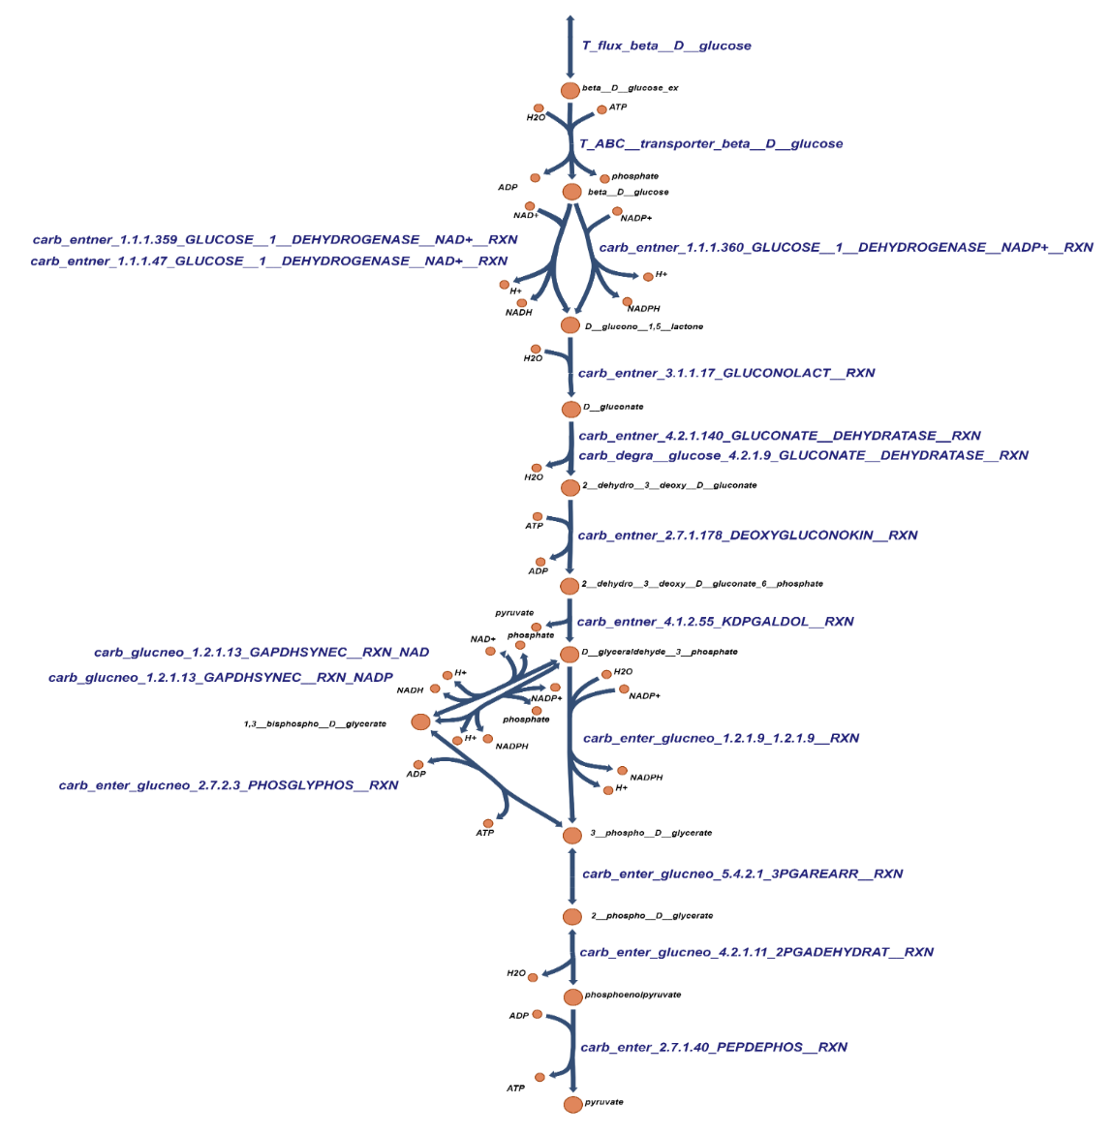

**Figure S12.** The reduced set of pathways used for investigating the difference between mRNA and maximum enzyme activities after mapping them to the genome-wide metabolic map.

**Table 6.** The enzyme activities in the cell crude extract and the absolute values of mRNA encoding enzymes of the small pathways.

|  |  |  |  |  |  |
| --- | --- | --- | --- | --- | --- |
| Reaction id | Enzyme name | Enzyme activities in cell crude extract (µmol min-1 gCE-1) | | mRNA (80 ℃) | mRNA (70 ℃) |
| 80 ℃ | 70 ℃ |  |  |
| T_ABC__transporter_beta__D__glucose | ABC transport | ----- ¹ | ----- | 184457 | 101448 |
| carb_entner_1.1.1.359_GLUCOSE__1__DEHYDROGENASE__NAD+__RXN | GDH **²** | 1170 | 270 | 131251 | 116348 |
| carb_entner_1.1.1.47_GLUCOSE__1__DEHYDROGENASE__NAD+__RXN | GDH **²** | 1170 | 270 | 131251 | 116348 |
| carb_entner_1.1.1.360_GLUCOSE__1__DEHYDROGENASE__NADP+__RXN | GDH **²** | 250 | 96 | 131251 | 116348 |
| carb_entner_3.1.1.17_GLUCONOLACT__RXN | GL | ----- | ----- | 1000000 ⁵ | 1000000 |
| carb_entner_4.2.1.140_GLUCONATE__DEHYDRATASE__RXN | GAD ³ | 170 | 92 | 836571.5 | 356251 |
| carb_degra__glucose_4.2.1.9_GLUCONATE__DEHYDRATASE__RXN | GAD **³** | 170 | 92 | 836571.5 | 356251 |
| carb_entner_2.7.1.178_DEOXYGLUCONOKIN__RXN | KDGK **³** | ----- | ---- | 291272.8 | 253355.8 |
| carb_entner_4.1.2.55_KDPGALDOL__RXN | KDPGA **³** | 120 | 55 | 597318.7 | 346968 |
| carb_glucneo_1.2.1.13_GAPDHSYNEC__RXN_NAD | GAPDH **³** | 87 | 43 | 653018.3 | 675898.5 |
| carb_glucneo_1.2.1.13_GAPDHSYNEC__RXN_NADP | GAPDH **³** | 87 | 43 | 653018.3 | 675898.5 |
| carb_enter_glucneo_2.7.2.3_PHOSGLYPHOS__RXN | PGK **²** | 110 | 30 | 599572.8 | 492960.8 |
| carb_enter_glucneo_1.2.1.9_1.2.1.9__RXN | GAPN **³** | 36 | 21 | 648866.8 | 295347 |
| carb_enter_glucneo_5.4.2.1_3PGAREARR__RXN | PGM **²** | 75 | 93 | 74533 | 100476.5 |
| carb_enter_glucneo_4.2.1.11_2PGADEHYDRAT__RXN | ENO **³** | ----- | ---- | 410775.3 | 425307.3 |
| carb_enter_2.7.1.40_PEPDEPHOS__RXN | PK **²** | 76 ⁴ | 70 | 192121 | 307618 |

¹ The symbol “ ---- “ mean that the activities of these enzymes have not been measured.

**²** Enzyme activities measured by Haferkamp (Patrick Haferkamp, 2011).

**³** Enzyme activities measured by Kouril (Theresa Kouril, 2012).

⁴Due to heat instability of PEP, the PK activity could only be determined at 70 °C, so here the number is the enzyme activity measured at 70 °C in crude extract of cells growing at 80 °C.

⁵ This reaction happens spontaneously, so we just used a high number for this reaction.

The file named “reaction_id_RAS” shown in the Github repository under the folder name “data” shows that the RNA level of GAPN at lower temperature (648866) is around twice that at high temperature (295347; see also Table 6). One might expect this to lead to a reduced GAPN flux at high temperature. The same applies to the Vmax levels. However, in the flux balance analysis described above for the mRNA results we did not see any predicted use of GAPN at all. This was caused by the fact that the RNA level of the PGAM is limiting. When mapping two different datasets (mRNA or enzyme activities) to the bounds of the reactions, we obtained different results. These might be caused by the fact that the genome wide metabolic map does not consider the regulation of the enzyme Vmaxs such as through inhibitory post translational modifications.

In order to check this, we referred to the kinetic models which contain the pathway from GAP to pyruvate (Figure 2A) (Zhang et al., 2017). These models were built based on the kinetic parameters measured *in vitro*. For the present study we replaced the enzyme Vmax for different reactions in the published model with the corresponding specific activity measured in the crude extract of the cell growing at 80 ℃ which was also measured at 80 ℃ *in vitro* by Kouril. The Vmax‘s for the crude extract of the cell growing at 70 ℃ as measured at 70 ℃, were used for comparison with those at 80 ℃ (Kouril, 2012). The value of the fluxes through GAPDH, PGK and GAPN are shown in Table 7. From this table 7, we infer that for this small pathway at high temperature the overall flux from GAP to pyruvate is higher than that at low temperature, which is in good agreement with the fact that *S. solfataricus* grows optimally at 80 ℃ (Kouri, 2012). Apart from difference in the overall flux between these two temperatures, there is also a large difference in the fluxes through GAPDH and PGK and GAPN. At low temperature the fluxes of GAPDH and PGK in the gluconeogenic direction were only 0.12 mM/min, while at the high temperature they are more than 70 times higher.

**Table 7**. Modelled fluxes (mM/min) at steady state for *S. solfataricus*. Pathways were shown in Figure. 2A.

|  |  |  |
| --- | --- | --- |
| **Cells‘ growth temperature / enzyme activity measuring temperature** | **80 °C / 80 °C** ¹ | **70 °C / 70 °C ²** |
| Overall flux | 20.5 | 17.1 |
| JGAPDH | -9.1 | -0.12 |
| JPGK | -9.1 | -0.12 |
| JGAPN | 29.5 | 17.2 |
| JPGAM | 20.5 | 17.1 |
| JENO | 20.5 | 17.1 |
| JPYK | 20.5 | 17.1 |

¹ Here we used the enzyme activity of the crude extract of the cells growing at 80 ℃ and measuring at 80 ℃. While the measuring of enzyme activity of PYK in the cell crude extract was lacking due to the heat instability of PEP, we just used the value obtained by measuring the crude extract of the cells extract growing at 80 ℃ and measuring at 70 ℃. As the enzyme activity of ENO has not been measured, we just used the value in the published model.

**²** Here we used the enzyme activity of the crude extract of the cells growing at 70 ℃ and measuring at 70 ℃. As the enzyme activity of ENO has not been measured, we just used the value in the published model.

4**. Discussion**

Many living organisms have a high ability to adapt to changes in their environment, such as changes of temperature, partial oxygen pressure, or substrate concentrations. The changes in the environment affect transporters, receptors and/or intracellular enzymes (Temperature) and the organisms then respond by metabolic or gene expression regulation (Ter Kuile and Westerhoff, 2001) of enzyme activities. Possibly the simplest case is that of running some more (or less) flux through all of the existing pathways. This happens when only the growth rate is adapted to an environmental change such as a minor reduction in the concentration of the growth substrate, leading to a proportional change in growth rate. This situation obtains when in a chemostat the dilution rate is reduced slightly or in an ecosystem where substrate concentrations may vary somewhat. It is however not the type of conditions that is often studied in laboratories. There more often the environmental challenge is qualitative, e.g. consists of the substitution of one type of growth substrate for another. The organism may then adapt fluxes by redirecting flux through pre-expressed pathways and by expressing more of the newly required pathway and less of the preexisting ones. We shall call this ‘metabolic switching’. It consists of the amplification or inactivation of entire pathways, without changing their quality or function.

In this paper we addressed a third type of adaptation, which occurs when there is a trade-off between two tasks of a single metabolic network, such as the provision of both Carbon building blocks and Gibbs energy to anabolism.

The thermodynamic driving force for growth () may be compromised in magnitude if one of the growth substrates becomes limiting in concentration. For thermophiles like *S. solfataricus* this could be the oxygen required for aerobic growth, as the tendency of oxygen to dissolve in water decreases by a factor of 4 between 25 C and 80 C. Often the drop in Gibbs energy between catabolic substrates and catabolic products comes with a large drop in enthalpy. This implies a strong reduction of that Gibbs energy with increasing absolute temperature, which is notable across GAPDH + PGK (Zhang et al., 2017). And whilst acidophiles keep most of their enzymes safe at their moderate intracellular pH only slightly lower than 7 (She et al., 2001), parts of their transporters are facing the extracellular medium at a pH below 4, and may thereby denature, making substrate uptake and thereby the intracellular substrate concentrations, limiting factors. One should therefore consider the relevance of changes in flux stoichiometries (‘Z’ or ‘n’) for conditions where ∆Gc is small relative to ∆Ga.

One reason for this is that we noted how readily Z can change provided that we do not limit the system to a single enzyme-catalyzed reaction but consider a metabolic network. In order to estimate the extent of this variation of the phenomenological stoichiometry *Z*, we used the non-equilibrium thermodynamic description mentioned above, but now for two parallel pathways driven by the same catabolic Gibbs energy drop and working against the same potential, . For two parallel pathways with ATP stoichiometries of *n1* and *n2,* we found that one should expect this stoichiometry to vary with the thermodynamic driving forces at play. This may have been a bit unexpected because in previous non equilibrium thermodynamic analyses, the ‘phenomenological stoichiometry’ Z was always treated as a constant, whilst the force ratio (/) or the degree of coupling q were considered to be adjustable or variable (Kedem & Caplan, 1965).

We also found that for every thermodynamic setting in terms of (/) a different value of the stoichiometry should be optimal for maximal synthesis of ATP and thereby growth rate. This also has implications for the optimum thermodynamic efficiency. For the optimum state that we identified above, the thermodynamic efficiency is smaller than 50%, for:

Microbial growth is very inefficient thermodynamically (H. V. Westerhoff et al., 1983) and perhaps this is part of the explanation; a part that is different from the explanation given in ( Westerhoff et al., 1983).

Our findings make this particularly understandable for the catabolic segment connecting GAP with 3-PGA. When anabolism is limited because of lack of anabolic substrate, the Gibbs energy of ATP hydrolysis will increase. In our kinetic model we found that the flux between GAP and 3 PGA through GAPDH and PGK may then invert, thereby making catabolism of glucose through this route impossible. The cell then needs to switch to one of the other routes with a lower ATP/ glucose ratio, such as the route through GAPN. This simulation also evidenced that in order to effect the shift to a lower stoichiometry Z no gene expression regulation should be needed; the usual kinetics of the system together with changes in metabolite concentrations should already cause gear shifting.

The situation of these organisms may then be similar to that of an automobile driving uphill, with the slope of the hill replacing , and with (minus) the Gibbs energy of combustion of the gasoline. With the slope of the hill becoming steeper, the velocity of the car in any given gear setting will decrease and at some point it will be better to switch to lower gear in order to maintain speed. There will be fewer turns of the car’s wheels for a given number of strokes of its pistons, but the piston strokes occur at a higher frequency than they would have done at the original gear setting. On a horizontal motorway the better state is the highest gear setting. It is for this analogy that we speak of the metabolic switch to a pathway with a different ATP to substrate ratio, as ‘gear shifting’.

Although switching to lower gear may increase the growth rate, it most often decreases both the growth yield and the thermodynamic efficiency of growth. Gear switching comes with a trade-off between growth rate on the one hand and growth yield and efficiency on the other. MacArthur and Wilson (1967) already addressed such a trade-off in their r/k-selection theory. r-selected species engage in high growth rates but with low probability of surviving to adulthood. K-selection species invest in sturdiness more than growth rate. The latter are typically strong competitors with almost every individual surviving to adulthood. Westerhoff et al (H. V. Westerhoff et al., 1983) calculated thermodynamic efficiencies of microbial growth and found that these were low. For substrates more oxidized than biomass the efficiencies were close to 20 %, the value predicted by Westerhoff et al. (H. V. Westerhoff et al., 1983) for maximal growth rate at optimal efficiency, i.e. the result consistent with an optimal trade-off between growth rate and efficiency. Microorganisms always maintained under balanced growth conditions such as in turbidostat, should be expected to have become selected for maximum growth rate, but for growth in repeated batch conditions with starvation periods in between such as in isolated drops of substrate (and in the practice of how microbial strains are maintained in the laboratory), selection for efficiency should contribute more to the survival of the organism than selection for growth rate (Westerhoff and Van Dam, 1987). The latter growth condition has since been used for the selection of strains with enhanced productivity (Tatenhove-pel et al., 2020) .

Whether there is r-selection such as apparently in our example of *S. solfataricus* (Figure 1) rather than k-selection should depend on the environment. Less-crowded environments should favor r-selection while in crowded places with the densities of a species close to the environment’s carrying capacity, k-selection should prevail (Pianka et al., 1972). This translates to a more crowded environment leading to substrate limitation hence a decreased and an increased and hence a decrease in optimal Z. A case in point should be oxygen limitation due to a crowded environment or a high temperature. Considering the alternative quinol oxidases soxABCD and soxM of *S. solfataricus* at low pO2, one should expect r (rate) selection to favor soxM (or sox ABCDE, both of which only pump two protons per pair of electrons) over Sox ABCD (which pumps 4 protons per two electrons). Yield (‘k-) selection should route the flux towards soxABCD.

In *S. solfataricus* at low-O2 conditions, the gene cluster of soxABCD is overexpressed, while under high-O2 conditions the expression of SoxM is upregulated (Simon et al., 2009): Through gene expression Z here increases with oxygen limitation, i.e. as increases, whereas through metabolic regulation Z should have decreased. Remarkably perhaps, the gene expression regulation is here consistent with k (yield) selection at low oxygen concentrations rather than to favor a fast synthesis of ATP and fast growth. The organism may prefer to grow at a higher yield, i.e. to have, per oxygen molecule available more ATP synthesized.

There are no data for the affinity of oxygen for SoxABCD and SoxM for *S. solfataricus*, but for *Aeropyrum pernix* K1, which is quite close to *S. solfataricus*, it has been reported that SoxM has lower affinity for O2 than SoxABCD (Ishikawa et al., 2002), i.e. a KMO2 of 5 µM for SoxABCD and 32 µM for SoxM.

We propose to use the term ‘gear shifting’ for cases where the organism alters the effective stoichiometry at which it makes ATP, for the purpose of its fitness, independent of whether this is a reduction or an increase in the stoichiometry.

In Biology one also finds a functionally similar yet biochemically different phenomenon: a switch to a different catabolic process with a concomitant change in the number of ATP’s delivered per substrate molecule catabolized. If the concentration of the growth substrate becomes lower, yeast cells for instance shift to respiration from fermentation with a concomitant reduction in growth rate (P. Van Hoek et al., 1998) (Chumnanpuen et al., 2014)(de Jong et al., 2014). This is not gear shifting *per se,* as the catabolic reaction changes, with CO2 only rather than ethanol plus CO2 as catabolic products from glucose. The catabolic Gibbs energy used per molecule of ATP hardly changes (a 15 % reduction [from 100 to 85 kJ/mol ATP] for a 15 fold increase in catabolic Gibbs energy). More similar to gear shifting is the case where the addition of the uncoupler benzoic acid to yeast enhanced the flux through glycolytic enzymes by a factor of 10 (Daran-lapujade et al., 2007); one could construe this as a reduction in ATP stoichiometry of catabolism and hence as gear shifting.

In *E.coli* at high glucose consumption, acetate is formed. The expression of NADH oxidase can then help alleviate the repression of many genes involved in the tricarboxylic acid (TCA) cycle, reduce acetate production, and increase biomass production (Vemuri et al., 2006). Under glucose limitation *L. lactis* changes from homolactic to heterolactic fermentation and this can be stimulated by overexpression of NADH oxidase (Hoefnagel et al., 2002). Both these cases are again examples of catabolic rewiring rather thanjust a change in ATP stoichiometries: although with heterolactic fermentation one more ATP is produced per glucose, as acetate plus formate plus ethanol are produced instead of just lactate.

With respect to explanations for gear shifting and catabolic switching, we may distinguish between the mechanistic and the teleological explanations. In terms of the former (Daran-lapujade et al., 2007) showed that metabolic regulation often plays an important role, in addition to some gene expression regulation taking place resulting in metabolic rewiring. Through such rewiring tumor cells may switch to glutamine catabolism for instance (Damiani et al., 2017)(Damiani et al., 2019). The mechanism behind mixed acid fermentation involves changes in the concentrations of both fructose 1,6 bisphosphate and lactate dehydrogenase (Thomas et al., 1979), i.e. again both metabolic and gene expression regulation. Metabolic regulation as the basis for gear shifting could be advantageous because it is fast. This could be useful for *S. solfataricus* in hot springs where it may be subject to strong variations in temperature and oxygen tension over short periods of time. Adaptation to steady extreme conditions is understood for various organisms, but adaptation to rapid variability in conditions is another matter. The present paper may constitute an entry point.

An example of how catabolic switching may contribute to fitness is found in yeast: when glucose is sufficient *Saccharomyces* will first accumulate ethanol no matter oxygen is there or not. The accumulated ethanol can then inhibit the growth of competing organisms, or can be used as a substrate when the glucose concentration is lower (Merico et al., 2007). *L. lactis* can excrete an extracellular protease to degrade milk proteins into freely utilizable peptides when the peptides in the environment are insufficient for the cells to grow. Not all the cells do this, as the protease will function outside of the cell and the peptide produced can also be used by neighboring cells (Bachmann et al., 2011). A similar phenomenon exists in yeast. When there is not enough substrate like glucose or fructose, some cells will start to produce invertase, which can catalyze the breakdown of sucrose. Other yeast cells (which are called ‘cheater’) do not produce this invertase. They just use the glucose or fructose degraded from sucrose by the invertase produced by yeast cells that are close by (Gore et al., 2009). In this condition, the signal is the substrate level and the yeast cells will switch between producing invertase and not producing invertase. The fitness function of gear shifting *sensu stricto* cannot be inferred from these examples, as they do involve changes in metabolism other than ATP yield. The function of gear shifting may be limited to an enhanced growth rate under energetically challenging circumstances or to overflow metabolism to reduce ATP levels in cases of energy affluence.

Knowing the potential of gear shifting is one thing but proving that it actually occurs is another. The most accurate and efficient way is to measure the flux of different pathways of the cells which are growing in chemostat. With perturbations, the flux among different pathways may change and the gear shifting might show. The fluxes through the pathways can be measured by using isotope- labeled substrate, and this method can show the gear shift directly (The isotope was not present in a pathway and then it was) and allows the dimension of time to be introduced. However, the shortcoming of this method to measure the gear shift is that it can only be used to measure gear shifting with pathways using the isotope labeled substrate. Another way to measure gear shifting is to measure growth yields. In chemostats growth yields have been shown to increase with the dilution rate and hence with the concentration of the growth limiting substrate. This has mostly been attributed to growth rate independent maintenance metabolism becoming less important quantitatively. As the resulting yields did not match the yields expected theoretically (Stouthamer et al., 1987)( Westerhoff et al., 1987) it has been proposed that there could also be growth rate dependent maintenance (Neijssel & Tempest, 1976). Westerhoff et al (1982) showed that this could be a consequence of the same mechanism of incomplete coupling between catabolism and anabolism that sits behind the growth rate independent maintenance (H. V. Westerhoff et al., 1982). Here we note that the decrease in growth yield with decreasing chemostat dilution rate could also be caused by gear shifting to lower catabolic stoichiometries.

If the regulation of gear shifting occurs through alterations in gene expression, one may measure transcript or protein levels using deep sequencing and mass spectrometry, respectively. This method has some advantages such as high throughput and capacity for automation. However, this method is based on the hypothesis that the mRNA or protein levels can represent the flux through the corresponding pathways; it does not address gear shifting through metabolic regulation (ter Kuile & Westerhoff, 2001).

The genome-wide metabolic map is useful because it includes the total metabolic and thereby part of the thermodynamic potential that an organism has available. We used this to show that there for *S. solfataricus* is no positive gear setting for the catabolism between glucose and pyruvate, i.e. there is no pathway in the GEMM between these two molecules that has a positive ATP yield. This of course depends on the glucose uptake system of the GEMM of *S. solfataricus* being an ATP dependent system rather than a proton or sodium simport or a glucose uniport such as in other organisms. It also depends on the fact that in this modified pathway in the reactions catalyzed by 2-dehydro-3-deoxy-phosphogluconate aldolase or 2-keto-3-deoxygluconate aldolase one product is pyruvate: the production of this pyruvate does not produce any ATP, while through the normal GAPDH - PGK pathway it will produce 2 molecules of ATP. Another reason is that it is thermodynamic infeasible for the export of lactic acid, as we have shown in section 3.2, in order to export the lactic acid from inside to outside, the inside concentration of lactic acid need to be 1000 M which is way too high for the living cells.

We conclude that gear shifting is a feasible option for extremophiles to head off thermodynamic threats. Whether it serves mesophiles equally well, remains to be seen.

**Acknowledgments:**

Yanfei Zhang thanks the China Scholarship Council for a PhD fellowship. The authors acknowledge Theresa Kouril who helps in the preparing of the manuscript. The authors thanks to collaborators in the group of J. van der Oost of the Wageningen University for supplying the transcriptomic data of the two biological samples (the cells growing at 70 and 80 ℃).

**Conflicts of Interest:** The authors declare that there is no conflict of interest.

**References**

Anemüller, S., & Schäfer, G. (1990). Cytochrome aa3 from Sulfolobus acidocaldarius. *Eur. J. Biochem.*, *305*, 297–305.

Bachmann, H., Molenaar, D., & Kleerebezem, M. (2011). High local substrate availability stabilizes a cooperative trait. *The ISME Journal*, 929–932. https://doi.org/10.1038/ismej.2010.179

Chumnanpuen, P., Hansen, M. A. E., Smedsgaard, J., & Nielsen, J. (2014). Dynamic metabolic footprinting reveals the key components of metabolic network in yeast saccharomyces cerevisiae. *International Journal of Genomics*, *2014*. https://doi.org/10.1155/2014/894296

Damiani, C., Colombo, R., Gaglio, D., Mastroianni, F., Pescini, D., Westerhoff, H. V., Mauri, G., Vanoni, M., & Alberghina, L. (2017). *A metabolic core model elucidates how enhanced utilization of glucose and glutamine , with enhanced glutamine- dependent lactate production , promotes cancer cell growth : The WarburQ effect*. 1–29.

Damiani, C., Maspero, D., Filippo, M. Di, Colombo, R., Pescini, D., Graudenzi, A., Westerhoff, V. H., Alberghina, L., Vanoni, M., & Mauri, G. (2019). *Integration of single-cell RNA-seq data into population models to characterize cancer metabolism*. 1–25.

Daran-lapujade, P., Rossell, S., Gulik, W. M. Van, Luttik, M. A. H., Groot, M. J. L. De, Slijper, M., Heck, A. J. R., Daran, J., Winde, J. H. De, Westerhoff, H. V, Pronk, J. T., & Bakker, B. M. (2007). *The fluxes through glycolytic enzymes in Saccharomyces cerevisiae are predominantly regulated at posttranscriptional levels*.

de Jong, B. W., Shi, S., Siewers, V., & Nielsen, J. (2014). Improved production of fatty acid ethyl esters in Saccharomyces cerevisiae through up-regulation of the ethanol degradation pathway and expression of the heterologous phosphoketolase pathway. *Microbial Cell Factories*, *13*(1), 1–10. https://doi.org/10.1186/1475-2859-13-39

Gleißner, M., Kaiser, U., & Antonopoulos, E. (1997). *The Archaeal SoxABCD Complex Is a Proton Pump in Sulfolobus acidocaldarius \**. *272*(13), 8417–8426. https://doi.org/10.1074/jbc.272.13.8417

Gore, J., Youk, H., & Oudenaarden, A. Van. (2009). Snowdrift game dynamics and facultative cheating in yeast. *Nature*, *459*(May), 253–256. https://doi.org/10.1038/nature07921

Hoefnagel, M. H. N., Starrenburg, M. J. C., Martens, D. E., Hugenholtz, J., Kleerebezem, M., Swam, I. I. Van, Bongers, R., Westerhoff, H. V, Snoep, J. L., & Wageningen, E. V. (2002). *Metabolic engineering of lactic acid bacteria , the combined approach : kinetic modelling , metabolic control and experimental analysis*. 1003–1013.

Kedem, O., & Caplan, S. R. (1965). Degree of coupling and its relation to efficiency of energy of conversion. *Trans. Faraday Soc.*, *21*, 1897–1911.

Kouri, T. (2012). Challenging metabolic networks at high temperature : The central carbohydrate metabolism of Sulfolobus solfataricus. *Thesis*.

Lübben, M., Warne, A., Albracht, S. P. J., & Saraste, M. (1994). The purified SoxABCD quinol oxidase complex of Sulfolobus acidocaldarius contains a novel haem. *Molecular Microbiology*, *13*(2), 327–335. https://doi.org/10.1111/j.1365-2958.1994.tb00426.x

Merico, A., Sulo, P., Piškur, J., & Compagno, C. (2007). Fermentative lifestyle in yeasts belonging to the Saccharomyces complex. *FEBS Journal*, *274*(4), 976–989. https://doi.org/10.1111/j.1742-4658.2007.05645.x

Molenaar, D., Van Berlo, R., De Ridder, D., & Teusink, B. (2009). Shifts in growth strategies reflect tradeoffs in cellular economics. *Molecular Systems Biology*, *5*(323), 1–10. https://doi.org/10.1038/msb.2009.82

Müller, F. H., Bandeiras, T. M., Urich, T., Teixeira, M., Gomes, C. M., & Kletzin, A. (2004). *Coupling of the pathway of sulphur oxidation to dioxygen reduction : characterization of a novel membrane-bound thiosulphate : quinone oxidoreductase*. *53*, 1147–1160. https://doi.org/10.1111/j.1365-2958.2004.04193.x

Neijssel, O. M., & Tempest, D. . (1976). Bioenergetic aspects of Aerobic growth of klebsiella aerogenes NCTC 418 in carbon-limited and carbon-sufficient chemostat culture. *Archives of Microbiology*, *107*, 215–221.

Orth, Jeffrey D., Ines Thiele, B. Ø. P. (2010). What is flux balance? *Nat. Biotechnol.*, *28*(3), 245–248. https://doi.org/10.1038/nbt.1614.What

Schäfer, G., Engelhard, M., & Müller, V. (1999). Bioenergetics of the Archaea. *Microbiology and Molecular Biology Reviews*, *63*(3), 570–620. https://doi.org/10.1128/mmbr.63.3.570-620.1999

Schafer, G., Purschke, W. G., Gleissner, M., & Schmidt, C. L. (1996). *Respiratory chains of archaea and extremophiles*. 16–20.

She, Q., Singh, R. K., Confalonieri, F., Zivanovic, Y., Allard, G., Awayez, M. J., Chan-weiher, C. C., Groth, I., Curtis, B. A., Moors, A. De, Erauso, G., Fletcher, C., Gordon, P. M. K., Jong, I. H., Jeffries, A. C., Kozera, C. J., Medina, N., Peng, X., Thi-ngoc, H. P., … Oost, J. Van Der. (2001). *The complete genome of the crenarchaeon Sulfolobus solfataricus P2*. *98*(14), 7835–7840.

Simon, G., Walther, J., Zabeti, N., Combet-Blanc, Y., Auria, R., Van Der Oost, J., & Casalot, L. (2009). Effect of O2 concentrations on Sulfolobus solfataricus P2. *FEMS Microbiology Letters*, *299*(2), 255–260. https://doi.org/10.1111/j.1574-6968.2009.01759.x

Stucki, J. W. (1980). The thermodynamic-Buffer Enzymes. *Eur. J. Biochem.*, *109*, 257–267.

Tatenhove-pel, R. J. Van, Hernandez-valdes, J. A., Kuipers, O. P., & Fischlechner, M. (2020). Microdroplet screening and selection for improved microbial production of extracellular compounds. *Current Opinion in Biotechnology*, *61*, 72–81. https://doi.org/10.1016/j.copbio.2019.10.007

ter Kuile, B. H., & Westerhoff, H. V. (2001). Transcriptome meets metabolome: Hierarchical and metabolic regulation of the glycolytic pathway. *FEBS Letters*, *500*(3), 169–171. https://doi.org/10.1016/S0014-5793(01)02613-8

Thauer, R., Jungermann, K., & Decker, K. (1977). Energy conservation in chemotrophic anaerobic bacteric. *Bacteriological Reviews*, *41*(1), 100–180. https://doi.org/10.1108/eb027807

Thomas, T. D., Ellwood, D. C., & Longyear, V. M. C. (1979). *Change from Homo- to Heterolactic Fermentation by Streptococcus lactis Resulting from Glucose Limitation in Anaerobic Chemostat Cultures*. *138*(1), 109–117.

Ulas, T., Riemer, S. A., Zaparty, M., Siebers, B., & Schomburg, D. (2012). Genome-Scale Reconstruction and Analysis of the Metabolic Network in the Hyperthermophilic Archaeon Sulfolobus Solfataricus. *PLoS ONE*, *7*(8). https://doi.org/10.1371/journal.pone.0043401

van Hoek, M. J. A., & Merks, R. M. H. (2012). Redox balance is key to explaining full vs. partial switching to low-yield metabolism. *BMC Systems Biology*, *6*. https://doi.org/10.1186/1752-0509-6-22

Van Hoek, P., Van Dijken, J. P., & Pronk, J. T. (1998). Effect of specific growth rate on fermentative capacity of baker’s yeast. *Applied and Environmental Microbiology*, *64*(11), 4226–4233. https://doi.org/10.1128/aem.64.11.4226-4233.1998

Vemuri, G. N., Altman, E., Sangurdekar, D. P., Khodursky, A. B., & Eiteman, M. A. (2006). *Overflow Metabolism in Escherichia coli during Steady-State Growth : Transcriptional Regulation and Effect of the Redox Ratio †*. *72*(5), 3653–3661. https://doi.org/10.1128/AEM.72.5.3653

Westerhoff, H. V., Hellingwerf, K., & Van Dam, K. (1983). Thermodynamic efficiency of microbial growth is low but optimal for maximal growth rate. *Proc. Natl. Acad. Sci. U*, *80*(January), 305–309.

Westerhoff, H. V., Lolkema, J. S., Otto, R., & Hellingwerf, K. J. (1982). Thermodynamics of growth non-equilibrium thermodynamics of bacterial growth the phenomenological and the Mosaic approach. *BBA Reviews On Bioenergetics*, *683*(3–4), 181–220. https://doi.org/10.1016/0304-4173(82)90001-5

Westerhoff, H. V., Winder, C., Messiha, H., Simenidis, E., Adamczyk, M., Verma, M., Bruggeman, F. J., & Dunn, W. (2009). *Systems Biology : The elements and principles of Life*. *583*(November), 3882–3890. https://doi.org/10.1016/j.febslet.2009.11.018

Zaparty, M., Esser, D., Gertig, S., Haferkamp, P., Kouril, T., Manica, A., Pham, T. K., Reimann, J., Schreiber, K., Sierocinski, P., Teichmann, D., van Wolferen, M., von Jan, M., Wieloch, P., Albers, S. V., Driessen, A. J. M., Klenk, H. P., Schleper, C., Schomburg, D., … Siebers, B. (2009). “Hot standards” for the thermoacidophilic archaeon Sulfolobus solfataricus. *Extremophiles*, *14*(1), 119–142. https://doi.org/10.1007/s00792-009-0280-0

Zhang, Y., Kouril, T., Snoep, J. L., Siebers, B., Barberis, M., & Westerhoff, H. V. (2017). The peculiar glycolytic pathway in hyperthermophylic archaea: Understanding its whims by experimentation in silico. *International Journal of Molecular Sciences*, *18*(4). https://doi.org/10.3390/ijms18040876

Anemüller, S., & Schäfer, G. (1990). Cytochrome aa3 from Sulfolobus acidocaldarius. *Eur. J. Biochem.*, *305*, 297–305.

Bachmann, H., Molenaar, D., & Kleerebezem, M. (2011). High local substrate availability stabilizes a cooperative trait. *The ISME Journal*, 929–932. https://doi.org/10.1038/ismej.2010.179

Carl R. Woese, O. K. and. (1990). Towards a natural system of organisms: proposal for the domains Archaea, Bacteria, and Eucarya. *Proc. Natl. Acad. Sci. U*, *87*, 4576–4579. https://doi.org/10.1136/bmj.1.4540.46

Daran-lapujade, P., Rossell, S., Gulik, W. M. Van, Luttik, M. A. H., Groot, M. J. L. De, Slijper, M., … Bakker, B. M. (2007). The fluxes through glycolytic enzymes in Saccharomyces cerevisiae are predominantly regulated at posttranscriptional levels.

Elferink, M. G. L., Albers, S. V., Konings, W. N., & Driessen, A. J. M. (2001). Sugar transport in Sulfolobus solfataricus is mediated by two families of binding protein-dependent ABC transporters. *Molecular Microbiology*, *39*(6), 1494–1503. https://doi.org/10.1046/j.1365-2958.2001.02336.x

Gasmi, N., Jacques, P. E., Klimova, N., Guo, X., Ricciardi, A., Robert, F., & Turcotte, B. (2014). The switch from fermentation to respiration in Saccharomyces cerevisiae is regulated by the Ert1 transcriptional activator/repressor. *Genetics*, *198*(2), 547–560. https://doi.org/10.1534/genetics.114.168609

Gore, J., Youk, H., & Oudenaarden, A. Van. (2009). Snowdrift game dynamics and facultative cheating in yeast. *Nature*, *459*(May), 253–256. https://doi.org/10.1038/nature07921

Haferkamp, P., Tjaden, B., Shen, L., Bräsen, C., Kouril, T., & Siebers, B. (2019). The carbon switch at the level of pyruvate and phosphoenolpyruvate in sulfolobus solfataricusP2. *Frontiers in Microbiology*, *10*(APR), 1–13. https://doi.org/10.3389/fmicb.2019.00757

Ishikawa, R., Ishido, Y., Tachikawa, A., Kawasaki, H., Matsuzawa, H., & Wakagi, T. (2002). Aeropyrum pernix K1, a strictly aerobic and hyperthermophilic archaeon, has two terminal oxidases, cytochrome ba3 and cytochrome aa3. *Archives of Microbiology*, *179*(1), 42–49. https://doi.org/10.1007/s00203-002-0496-1

Koning, S. M., Albers, S. V., Konings, W. N., & Driessen, A. J. M. (2002). Sugar transport in (hyper)thermophilic archaea. *Research in Microbiology*, *153*(2), 61–67. https://doi.org/10.1016/S0923-2508(01)01289-X

Mondeel, T. D. G. ., Rehman, S., Zhang, Y., Verma, M., Durre, P., Barberis, M., & Westerhoff, H. V. (2016). ScienceDirect Maps for when the living gets tough : Maneuvering through a hostile energy Maps for when the living gets tough : Maneuvering through a hostile energy Maps landscape. *IFAC PapersOnLine*, *49*(26), 364–370. https://doi.org/10.1016/j.ifacol.2017.03.002

Orth, Jeffrey D., Ines Thiele, B. Ø. P. (2011). Analysis?, What is flux balance, *28*(3), 245–248. https://doi.org/10.1038/nbt.1614.What

Pis, J., Polakova, S., Merico, A., & Compagno, C. (2006). How did Saccharomyces evolve to become a good brewer ?, *22*(4), 2–5.

Schäfer, G., Engelhard, M., & Müller, V. (1999). Bioenergetics of the Archaea. *Microbiology and Molecular Biology Reviews : MMBR*, *63*(3), 570–620. Retrieved from http://www.ncbi.nlm.nih.gov/pubmed/10477309%0Ahttp://www.pubmedcentral.nih.gov/articlerender.fcgi?artid=PMC103747

Simon, G., Walther, J., Zabeti, N., Combet-Blanc, Y., Auria, R., Van Der Oost, J., & Casalot, L. (2009). Effect of O2 concentrations on Sulfolobus solfataricus P2. *FEMS Microbiology Letters*, *299*(2), 255–260. https://doi.org/10.1111/j.1574-6968.2009.01759.x

Stetter, K. O. (1999). Extremophiles and their adaptation to hot environments. *FEBS Letters*, *452*(1–2), 22–25. https://doi.org/10.1016/S0014-5793(99)00663-8

ter Kuile, B. H., & Westerhoff, H. V. (2001). Transcriptome meets metabolome : hierarchical and metabolic regulation of the glycolytic pathway, *500*, 169–171.

Thomas, T. D., Ellwood, D. C., & Longyear, V. M. C. (1979). Change from Homo- to Heterolactic Fermentation by Streptococcus lactis Resulting from Glucose Limitation in Anaerobic Chemostat Cultures, *138*(1), 109–117.

Ulas, T., Riemer, S. A., Zaparty, M., Siebers, B., & Schomburg, D. (2012). Genome-Scale Reconstruction and Analysis of the Metabolic Network in the Hyperthermophilic Archaeon Sulfolobus Solfataricus. *PLoS ONE*, *7*(8). https://doi.org/10.1371/journal.pone.0043401

Vemuri, G. N., Altman, E., Sangurdekar, D. P., Khodursky, A. B., & Eiteman, M. A. (2006). Overflow Metabolism in Escherichia coli during Steady-State Growth : Transcriptional Regulation and Effect of the Redox Ratio †, *72*(5), 3653–3661. https://doi.org/10.1128/AEM.72.5.3653

Verduyn, C., Zomerdijk, T. P. L., Dijken, J. P. Van, & Scheffers, W. A. (1984). Continuous measurement of ethanol production by aerobic yeast suspensions with an enzyme electrode, 181–185.

Węglarz-Tomczak, E., Mondeel, T. D. G. A., Piebes, D. G. E., & Westerhoff, H. V. (2019). Nature and Nurture integrated through an adjustable Flux Balance Analysis: The impact of cell-nutrition changes on the Warburg effect in hepatocellular carcinoma. *BioRxiv*, 674150. https://doi.org/10.1101/674150

Wolf, J., Stark, H., Fafenrot, K., Albersmeier, A., Pham, T. K., Müller, K. B., … Siebers, B. (2016). A systems biology approach reveals major metabolic changes in the thermoacidophilic archaeon Sulfolobus solfataricus in response to the carbon source L-fucose versus D-glucose. *Molecular Microbiology*, *102*(5), 882–908. https://doi.org/10.1111/mmi.13498

Zhang, Y., Kouril, T., Snoep, J. L., Siebers, B., Barberis, M., & Westerhoff, H. V. (2017). The peculiar glycolytic pathway in hyperthermophylic archaea: Understanding its whims by experimentation in silico. *International Journal of Molecular Sciences*, *18*(4). https://doi.org/10.3390/ijms18040876

|  |  |
| --- | --- |
| copyRight | © 2019 by the authors. Submitted for possible open access publication under the terms and conditions of the Creative Commons Attribution (CC BY) license (<http://creativecommons.org/licenses/by/4.0/>).  Access: |